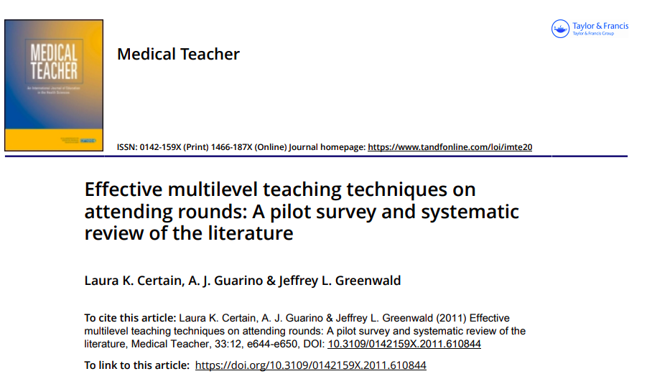

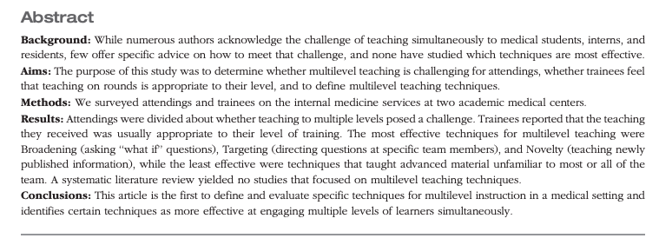

The results of the surveys in this article are not as important for our purposes as is the review of the techniques available for including learners of different levels when teaching on rounds. The chart below describes several possible techniques, and the bar graph reports which techniques trainees said was most effective. After you review the chart below, you’ll be asked to give examples of how you could incorporate the “broadening” and “targeting” techniques into your teaching.
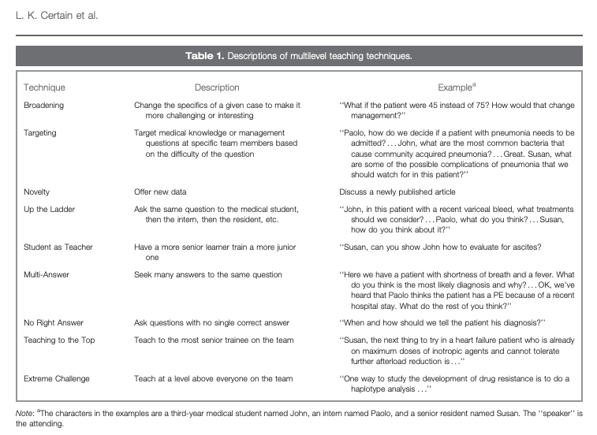

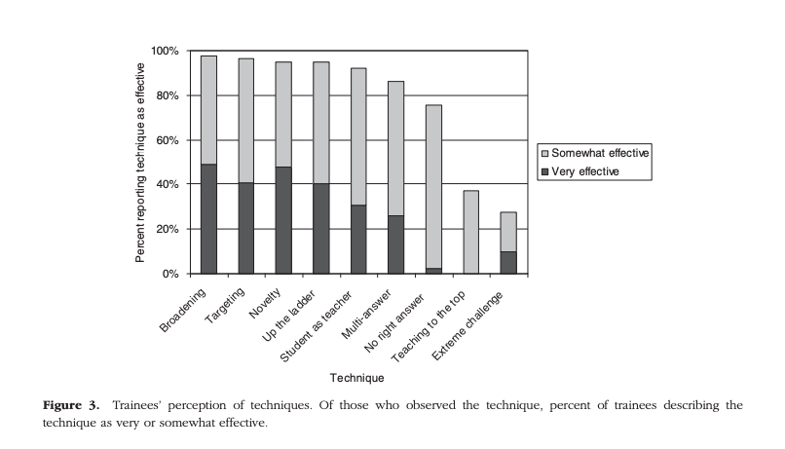

Broadening - “What if…?” questions

Write three “What if…?” questions that you can use on rounds.

e.g. During a typical consult for a pre-op evaluation: What if this patient had a mechanical aortic valve? How would we manage the anticoagulation peri-operatively?
1.

2.

Targeting

Give two examples of how you could use the “targeting” approach. For each scenario, write the questions you would ask to 2 different levels of learners (e.g. student, resident, or fellow).

Example scenario: While discussing a patient with heart failure with reduced EF (HFrEF):
- To the resident – Which medications for HFrEF have mortality benefit?
- To the fellow – What are the indications for BiV pacing for a patient with HFrEF?

Scenario 1:

Scenario 2:

