Ambulatory Cardiovascular Care:

General goals: The goal of the ambulatory care rotation is to provide fellows with training in both consultative and longitudinal care for patients with a variety of cardiovascular and associated conditions. Fellows will attend weekly clinics, maintain continuity by participating in patient’s care during hospitalizations and communicating test results directly, and interact with family members as well as referring and collaborating physician and health care professionals. Fellows will also interact professionally with patients, families, and all members of the ambulatory cardiology team.

Objectives (level-based):
1st year fellow:
-Recognize the differential diagnosis of chest pain and determine appropriate diagnostic work up.
-Recognize the differential diagnosis of dyspnea and determine appropriate diagnostic work up.
-Review indications for cardiac testing, including stress testing, echocardiography (transthoracic and transesophageal), coronary angiography, CT, and MRI.
-Perform complete history and physical exam, refining aspects of the cardiovascular exam.
-Formulate assessment and plan with attending supervision.
-Review differential diagnosis for palpitations, lightheadedness, and syncope, as well as appropriate diagnostic work up.
-Integrate information from diagnostic testing to optimize patient care.
-Identify high-risk features that require close follow up and/or inpatient admission.
-Understand the role of preoperative risk stratification and indications for cardiac testing.
-Effectively communicate findings by completing progress note in a timely manner and communicating with the referring physician or health care professional when indicated.
-Effectively communicate with patients and their families about patient’s condition, plan of care, and prognosis, initially with assistance from the supervising attending.
-Review evidence and guidelines pertaining to ambulatory cardiovascular care, including hypertension, lipid management, primary prevention, and diabetes management.
-Understand the role of lifestyle changes in management of cardiovascular disease.
-Recognize the role of stress, anxiety, depression, and other mental health comorbidities in cardiovascular disease.
-Interpret electrocardiograms accurately.

2nd-3rd year fellow: In addition to the above,
-Formulate a differential diagnosis as well as detailed assessment and plan independently.
-Manage patients with a wide variety of cardiovascular conditions including but not limited to hypertension, hyperlipidemia, stable ischemic heart disease, congestive heart failure, arrhythmias, valvular heart disease, pericardial disease, and peripheral vascular disease.
-Apply clinical guidelines and evidence-based medicine consistently.
-Review the clinical manifestations and diagnostic work up for peripheral vascular disease.
-Determine appropriate medication regimen and recognize side effects as well as non-adherence.
-Review indications for cardiac rehabilitation and collaborate with facilities to optimize patient care.
-Provide guidance to patients on physical activity appropriate to their condition.
-Independently conduct discussions with patients and families regarding patient’s condition, plan of care, and prognosis, and recognize indications for palliative care.

Attending responsibilities: (program specific)

Suggested reading:
Hurst, J. W., Fuster, V., Walsh, R. A., & Harrington, R. A. (2011). Hurst's the heart. New York: McGraw-Hill Medical.

Bonow, RO., Mann, DL., Zipes, DP., & Libby, P. (2011). Braunwald's Heart Disease: A Textbook of Cardiovascular Medicine. 9th edition. Elsevier Science.

ACC/AHA Clinical Practice Guidelines (https://www.acc.org/guidelines)

Evaluation of trainee: (program specific)

Evaluation of rotation: (program specific)

Core Competency Components and Curricular Milestones

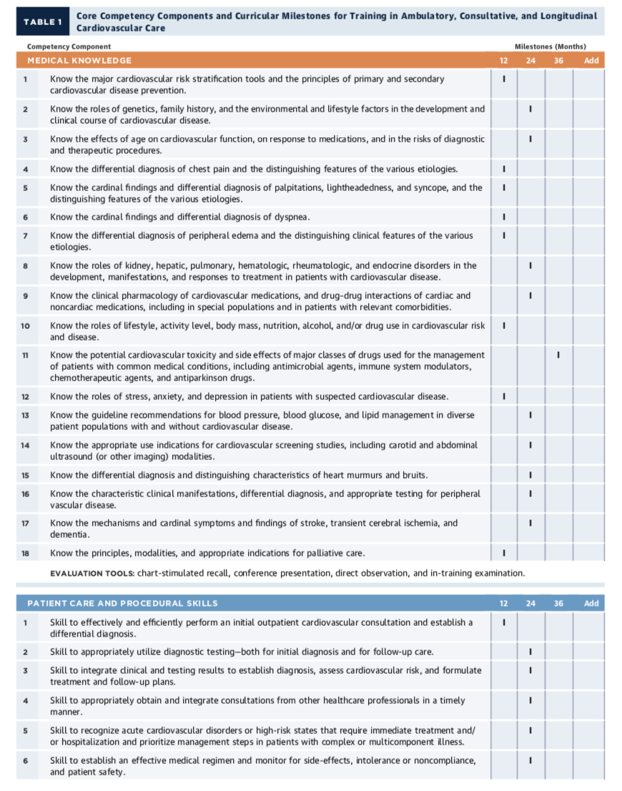
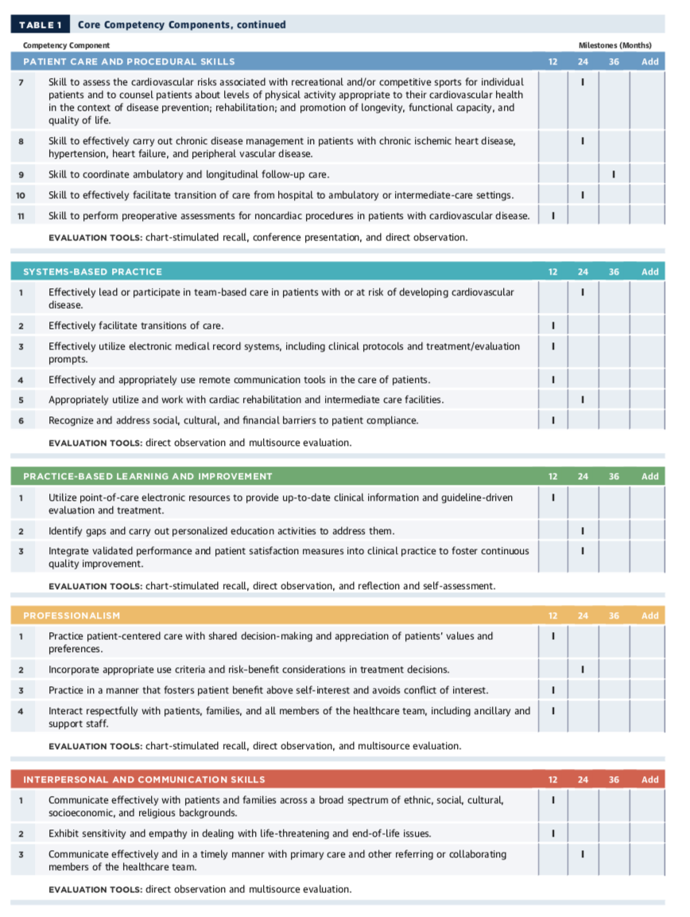ACC 2015 Core Cardiovascular Training Statement (COCATS 4). J Am Coll Cardiol. 2015;65:1721-1906.

