Cardiac Catheterization Rotation:

General goals: The goal of the cardiac catheterization rotation is to train fellows in the diagnostic and therapeutic role of cardiac catheterization in the management of all types of cardiovascular disease including coronary, structural, primary myocardial, pericardial, congenital, peripheral, and cerebrovascular disease. Fellows will also be expected to attend a weekly cardiac catheterization conference designed to address the role of cardiac catheterization/intervention in various disease processes. Fellows will also be expected to interact professionally with patients, families, and all members of the invasive cardiology team.

Objectives
1st year fellow (1-2 months):
-Know indications and contraindications for right and left heart catheterization as well as associated complications.
-Explain the procedure, potential complications, risks/benefits/alternatives to patients and families and obtain informed consent.
-Recognize comorbidities that lead to increased risk and the appropriate interventions to mitigate risk (including kidney disease).
-Understand fundamentals of radiation safety.
-Understand mechanism of action of anesthetic, antiplatelet, anticoagulant, and vasoactive medications.
-Perform intravascular catheter insertion to obtain both arterial and venous access (with ultrasound when indicated) and obtain hemostasis.
-Recognize coronary anatomy, variations, congenital abnormalities, and coronary blood flow physiology.
-Perform coronary angiography and catheter manipulation under supervision.
-Interpret coronary angiography with assistance.
-Perform right heart catheterization under supervision.
-Review fundamentals of hemodynamics in patients with valvular disease and heart failure.
-Perform left ventriculography under supervision and determine left ventricular ejection fraction.
-Manage complications of cardiac catheterization.
-Understand peripheral vascular anatomy.
-Understand indications, contraindications, and complications of peripheral vascular angiography.
-Review indications and potential complications of pericardiocentesis.
-Review indications and potential complications of endomyocardial biopsy.

2nd year fellow (3-4 months): In addition to the above,
-Review fundamentals of hemodynamics in patients with myocardial, pericardial, and pulmonary vascular diseases.
-Integrate findings of coronary angiography, ventriculography, and hemodynamic assessments to formulate appropriate management plan in the context of the clinical scenario.
-Review indications for percutaneous coronary intervention.
-Recite indications for vascular closure devices and associated complications.
-Assist in procedures of unstable and complex patients, including those with acute coronary syndromes, complex valvular heart disease, and congenital heart disease.
-Interpret coronary angiography, graft angiography, ventriculography, and right heart catheterization hemodynamic data independently.
-Complete COCATS level 1 training which includes participation in at least 100 diagnostic cardiac catheterization procedures. Of these, at least 50 should involve coronary angiography and at least 25 should involve hemodynamic assessment of valvular, myocardial, pericardial, or congenital heart disease.

3rd year fellow (5-6 months): In addition to the above,
-Perform diagnostic coronary angiography, ventriculography, and left and right heart catheterization independently.
-Perform peripheral angiography independently.
-Place intra-aortic balloon pump in emergent situations.
-Perform pericardiocentesis.
-Perform endomyocardial biopsy.
-Perform transvenous pacemaker insertion.
-Assist in percutaneous coronary interventions.
-Complete COCATS level 2 training which includes performance of at least 300 diagnostic cardiac catheterization procedures. For peripheral vascular angiography competency, participation in at least 100 invasive diagnostic peripheral vascular (non-carotid) angiographic procedures is required.

Fellow responsibilities: (program specific)

Attending responsibilities: (program specific)

Suggested reading:
Kern’s Cardiac Catheterization Handbook; Paul Sorajja, Michael Lim, Morton Kern
Grossman and Baim’s Cardiac Catheterization, Angiography, and Intervention; Mauro Moscucci

Evaluation of trainee: (program specific)

Evaluation of rotation: (program specific)

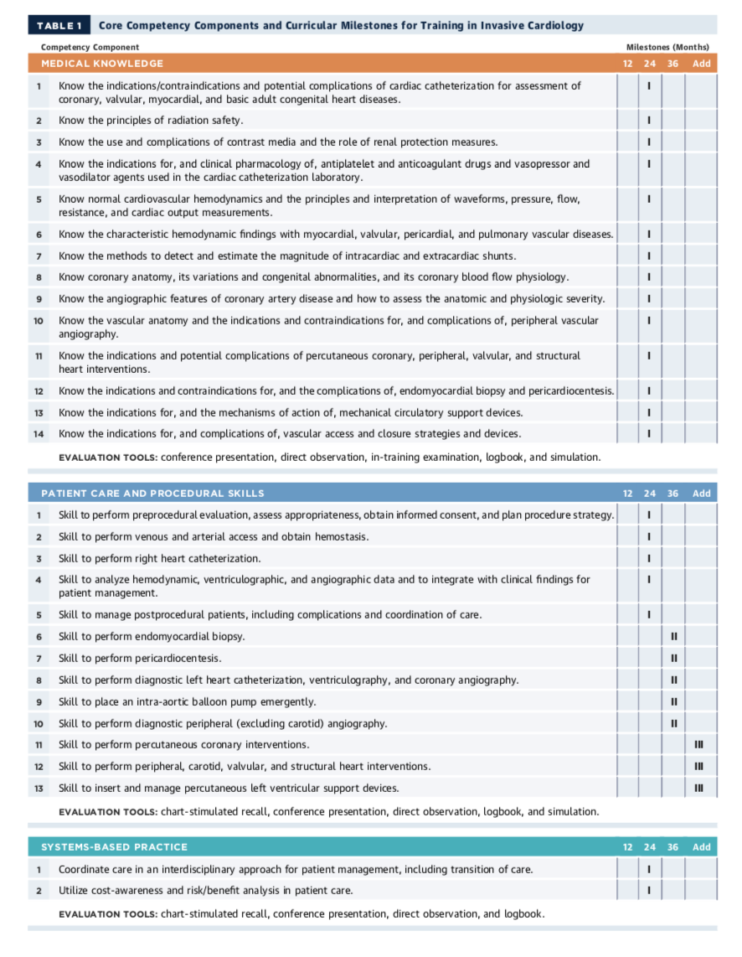

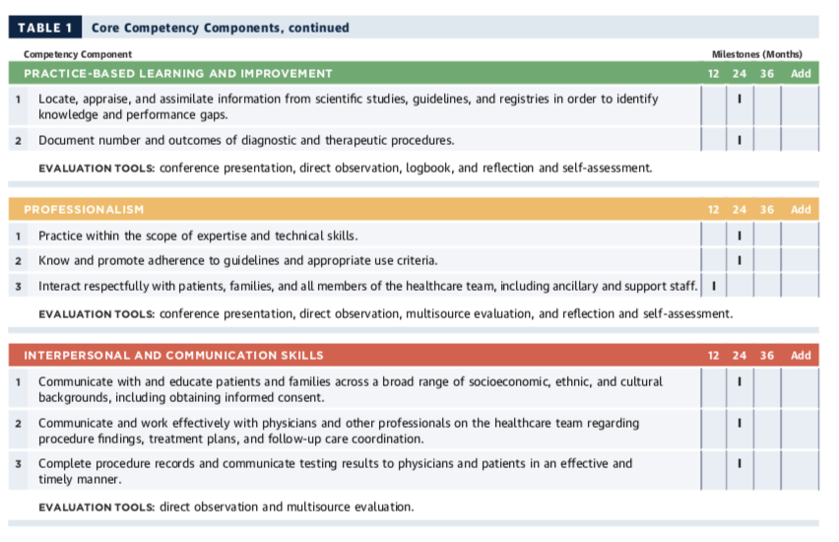

ACC 2015 Core Cardiovascular Training Statement (COCATS 4). J Am Coll Cardiol. 2015;65:1721-1906.

