Cardiology Consults Rotation:

General goals: The goal of the inpatient cardiology consult rotation is to train fellows in the care of inpatients with a variety of cardiovascular conditions and medical comorbidities. Fellows will be expected to lead and educate a team of housestaff and students as well as collaborate with the primary services by communicating their findings in a clear and timely manner. Fellows will also be expected to interact professionally with patients, families, and all members of the cardiology consult team.

Objectives:
1st year fellow (1-2 months):
-Perform complete history and physical exam, refining aspects of the cardiovascular exam.
-Recognize the differential diagnosis of chest pain and determine appropriate diagnostic work up.
-Integrate information from diagnostic testing to optimize patient care.
-Interpret electrocardiograms accurately, particularly for patients with possible acute coronary syndrome and arrhythmias.
-Formulate differential diagnosis as well as detailed assessment and plan, with attending supervision.
-Review indications for cardiac testing, including stress testing, echocardiography (transthoracic and transesophageal), coronary angiography, CT, and MRI.
-Execute appropriate triage of patients, including identification of high-risk patients that may require immediate intervention or transfer to higher level of care.
-Review evidence and guidelines pertaining to consult questions.
-Recognize own limits of knowledge and seek help appropriately.
-Receive consult requests courteously and render consults in a timely fashion.
-Accept responsibility for communication between teams and prompt documentation.
-Effectively communicate findings in a timely manner both by speaking with a member of the referring team and documenting findings in a progress note.
-Effectively communicate with patients and their families about patient’s condition, plan of care, and prognosis, initially with assistance from the supervising attending.
-Engage in education of residents and students on the consult team as well as the referring teams.

2nd-3rd year fellow (3-4 months): In addition to the above,
-Formulate differential diagnosis as well as detailed assessment and plan independently.
-Manage patients with a wide variety of cardiovascular conditions including but not limited to possible acute coronary syndrome, congestive heart failure, arrhythmias, syncope, infective endocarditis, valvular heart disease, pericardial disease, and peripheral vascular disease.
-Lead the consult team by assuming primary responsibility for patient care, triaging, communicating findings with referring teams and patients/families, and educating housestaff and students.
-Independently conduct discussions with patients and families regarding patient’s condition, plan of care, and prognosis, and recognize indications for palliative care.
-Participate in successful transition of care from inpatient to outpatient setting.
-Apply guidelines and evidence-based medicine consistently.

Attending responsibilities: (program specific)

Suggested reading:
Hurst’s the Heart; Valentin Fuster et al.
Braunwald’s Heart Disease; Douglas P. Zipes, et al.
ACC/AHA Clinical Practice Guidelines (https://www.acc.org/guidelines)

Evaluation of trainee: (program specific)

Evaluation of rotation: (program specific)

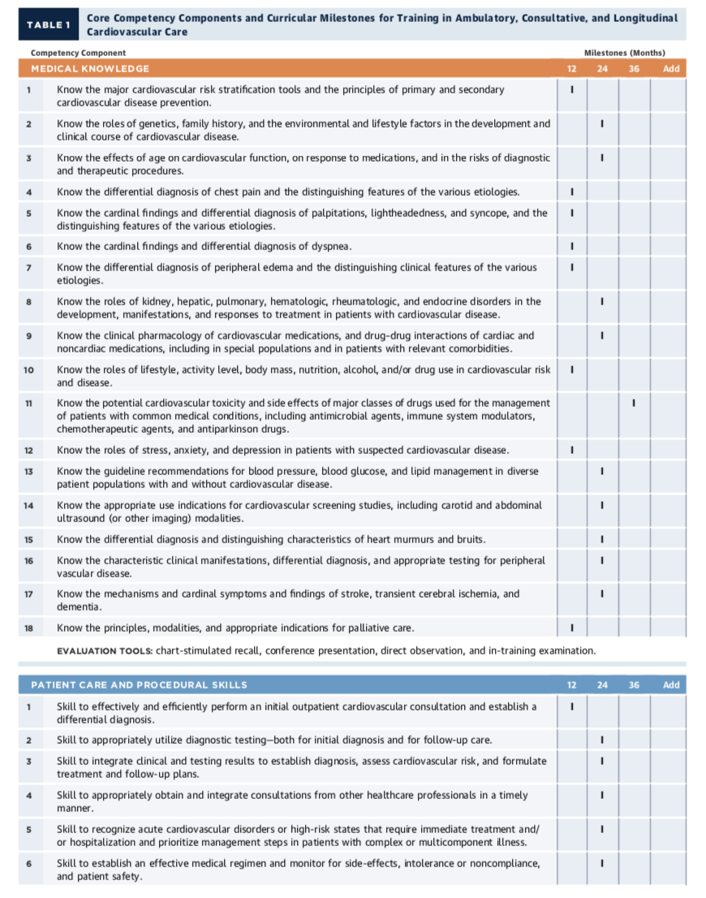

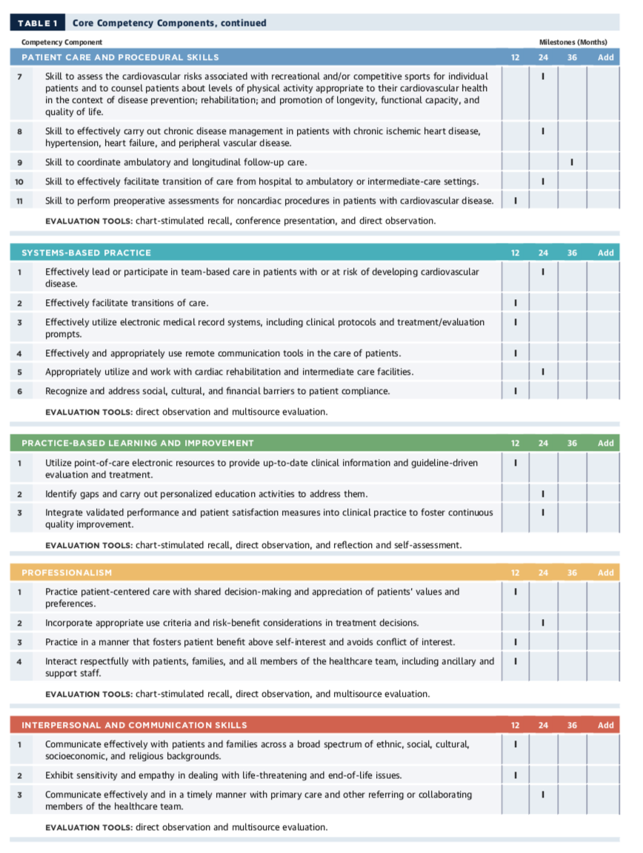ACC 2015 Core Cardiovascular Training Statement (COCATS 4). J Am Coll Cardiol. 2015;65:1721-1906.

