Cardiac Electrophysiology Rotation:

General goals: The goal of the cardiac electrophysiology rotation is to train fellows in the diagnosis, evaluation, and management of cardiac arrhythmias, including pharmacology, implantable electrical devices, and ablation. Fellows will rotate as a part of the cardiac arrhythmia team and participate in evaluation of patients, ECG/telemetry interpretation, interrogation of pacemakers and implantable cardioverter-defibrillators, formulation of management plan, and participate in electrophysiologic procedures. The fellow will interact professionally with patients, family members, and all members of the healthcare team, as well as engage in shared decision-making with patients.

Objectives:
1st year fellow (1 month):
-Obtain appropriate history and physical, review relevant ECG/telemetry findings, and formulate assessment and plan for inpatient consults.
-Identify characteristics of normal sinus rhythm and understand mechanism of sinus node dysfunction.
-Explain pathophysiology and ECG findings of atrial fibrillation and atrial flutter.
-Understand the fundamentals of managing atrial fibrillation and atrial flutter, including rate versus rhythm control and indications/contraindications of anticoagulation to reduce the risk of stroke.
-Identify types and mechanisms of atrioventricular block and determine appropriate work up and management.
-Begin to describe indications, contraindications, and associated complications of permanent pacemaker placement, implantable cardioverter-defibrillator placement, and cardiac resynchronization therapy.
-Identify differential diagnosis, ECG characteristics, evaluation, and management for supraventricular tachycardias.
-Begin performing basic device interrogation, including identification of arrhythmia events and understanding of programming modes.
-Understand differential diagnosis, evaluation, and management of syncope.
-Develop approach for diagnosis of wide complex tachycardia.
-Perform synchronized direct current cardioversion under supervision.
-Perform defibrillation of unstable ventricular arrhythmias.
-Know the basics of radiation safety.

2ndyear fellow (1-2 months): In addition to the above,
-Describe mechanisms of action of antiarrhythmic medications and understand indications/contraindications as well as parameters for monitoring.
-Understand pathophysiology, mechanism of action, evaluation, and management of non-sustained and sustained ventricular tachycardia.
-Describe the differential diagnosis and management of re-entrant and atrial tachycardias.
-Understand the significance of inherited diseases (including congenital heart disease, ion channel abnormalities, and structural heart conditions) in the evaluation and management of cardiac arrhythmias.
-Describe the risk stratification and management of sudden cardiac death, including in athletes.
-Detail indications and risk for non-invasive testing in evaluation of arrhythmias, including ambulatory monitoring, implantable loop recorder, and tilt table testing.
-Understand indications, limitations, and associated complications of non-invasive testing, as well as invasive electrophysiological testing and catheter ablation.
-Identify ventricular pre-excitation and understand diagnostic evaluation and management.
-Independently perform complete device interrogation and basic programming changes.
-Know all indications, contraindications, and associated complications of permanent pacemaker placement, implantable cardioverter-defibrillator placement, and cardiac resynchronization therapy.
-Place temporary pacemaker under supervision (may also occur in cardiac catheterization laboratory or cardiac intensive care unit).
-Complete COCATS level 1 training which includes at least 2 months rotating on the electrophysiology service as well as a minimum of 20 cardioversions and placement of 5 temporary pacemakers.

3rd year fellow (3-6 months): In addition to the above,
-Execute device interrogation, advanced programming changes, and troubleshooting of permanent pacemakers (single chamber, dual chamber, and biventricular) and implantable cardioverter-defibrillators.
-Perform remote device interrogation.
-Perform under supervision permanent pacemaker implantation of both single-chamber and dual-chamber devices as well as manage associated complications.
-Perform under supervision implantable loop recorder insertion, as well as interpretation and integration of results into patient management.
-Perform tilt table testing if available at institution.
-Complete COCATS level 2 training with a total of 6 months.
-Without pacemaker implantation: Complete at least 100 device interrogations/programming and at least 25 remote device interrogations
-With pacemaker implantation: In addition to the above, complete at least 40 permanent pacemaker implantations (at least 20 single chamber devices and at least 20 dual-chamber pacemaker implantations).

Fellow responsibilities: (program specific)

Attending responsibilities: (program specific)

Suggested reading:
Marriott’s Practical Electrocardiography; Galen S. Wagner and David G. Strauss
Clinical Arrhythmology and Electrophysiology, A Companion to Braunwald; Ziad Issa, John M. Miller, and Douglas P. Zipes
Josephson's Clinical Cardiac Electrophysiology - Mark E. Josephson MD

Evaluation of trainee: (program specific)

Evaluation of rotation: (program specific)
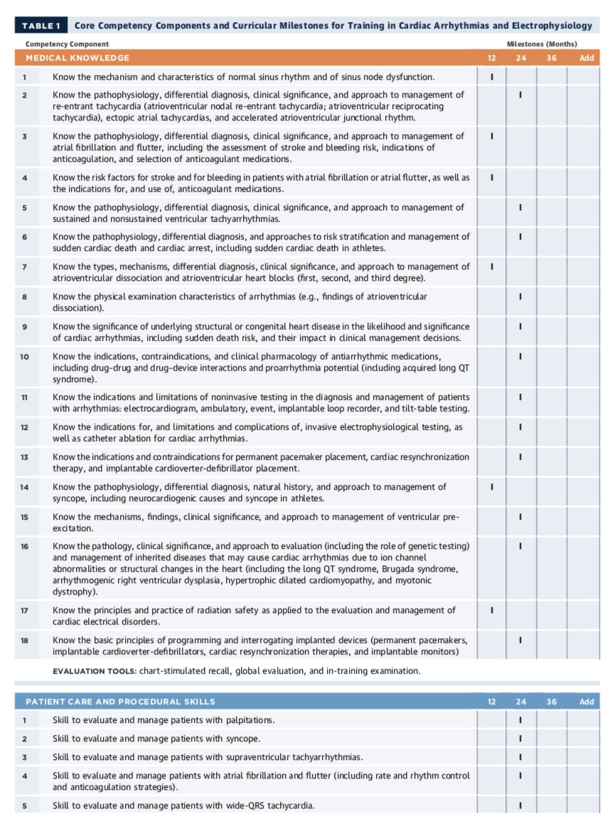
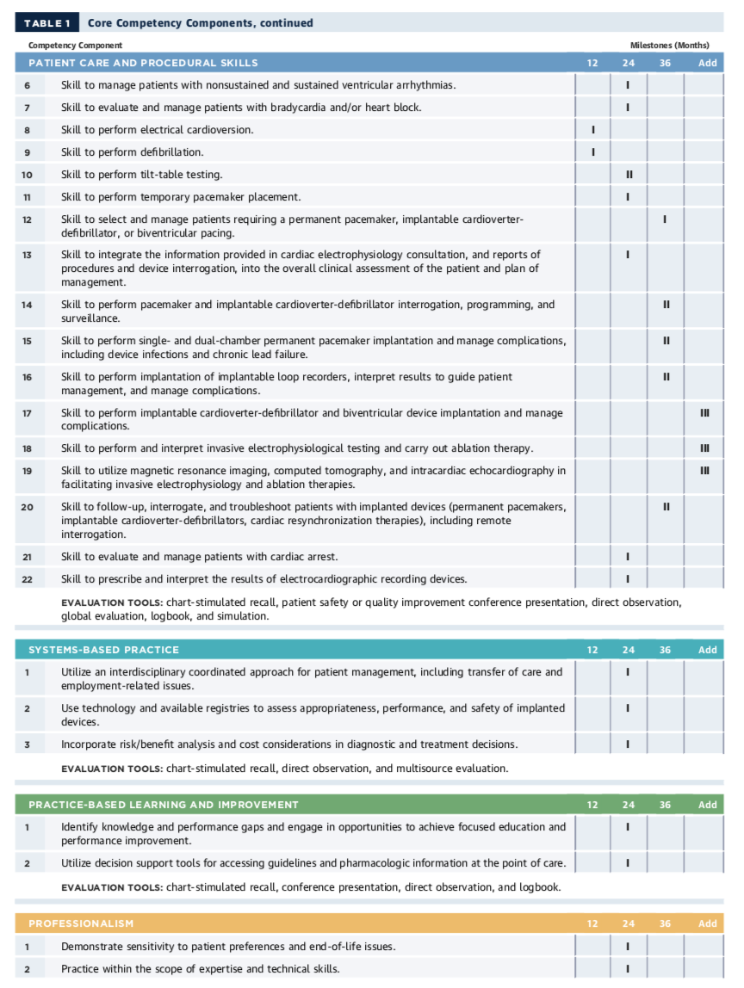

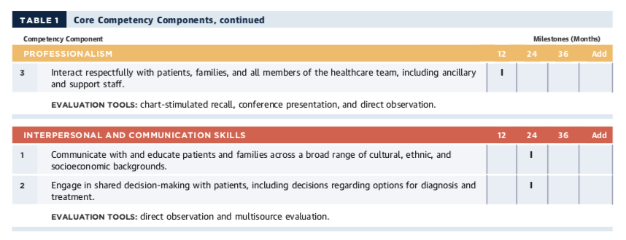

ACC 2015 Core Cardiovascular Training Statement (COCATS 4). J Am Coll Cardiol. 2015;65:1721-1906.

