Echocardiography Rotation:

General goals: The goal of the echocardiography rotation is to train all fellows in the performance and interpretation of echocardiography including M-mode, 2-dimensional (2-D), 3-dimensional (3-D), and Doppler (pulsed wave, continuous wave, color, and tissue). Every trainee should also understand the following: appropriate indications for echocardiography, fundamentals of ultrasound physics, instrumentation, integration of echocardiography into clinical care including application of hemodynamics, relationship to physical exam, impact of findings on patient management, and relationship to other imaging modalities. Fellows will learn transthoracic (TTE), transesophageal (TEE), stress, and contrast echocardiography. Further training in echocardiography can be offered for those interested in pursuing an academic career in echocardiography and will include advanced training in TEE, stress, interventional, and intraoperative echocardiography. Finally, fellows rotating through the echocardiography laboratory will appreciate their role as a member of the healthcare team, act in a professional manner with other members of the echocardiography team as well as patients, family members, and colleagues caring for patients.

Objectives:
1st year fellow (1-2 months):
-Perform a complete transthoracic echocardiogram independently and interpret with guidance.
-Understand “knobology” and how to use the machine.
-Identify limitations and artifacts of an echocardiographic examination.
-Recognize the standard views of a TTE.
-Determine left ventricular systolic function.
-Describe echocardiographic parameters used to assess diastolic function.
-Possess the skills needed to execute a limited TTE to answer a clinical question in an emergency setting.
-Classify severity of valvular stenosis and regurgitation (at least qualitatively).
-Describe the indications and contraindications for stress echocardiography (exercise and dobutamine), protocols of how to perform, and criteria for a positive test.
-Recognize the role of echocardiography in assessment of suspected infective endocarditis.
-Identify pericardial effusion and signs of cardiac tamponade.
-Ideally perform 75 transthoracic studies under the supervision of the laboratory director, designated faculty, and/or cardiac sonographers and interpret 150 TTEs. (COCATS Level 1)

2nd year fellow (3-4 months): In addition to the above,
-Interpret a TTE independently for common clinical conditions.
-Recognize and obtain the standard views of a TEE.
-Demonstrate how to safely intubate for a TEE.
-Learn moderate sedation for TEE.
-Perform and interpret a stress echocardiogram for ischemic heart disease.
-Apply quantitative methods to asses native valve disease and describe their limitations.
-Recognize how to assess right ventricular size and function.
-Identify characteristic findings of congenital heart disease (atrial septal defect, AV canal defect, ventricular septal defect, Ebstein’s anomaly, tetralogy of Fallot, coarctation of aorta, transposition of the great arteries, Fontan procedure, cor triatriatum, persistent arterial canal, Marfan syndrome)
-Describe the physiology of diastolic dysfunction.
-Describe the physiology of pericardial disease and recognize how to differentiate between restrictive cardiomyopathy and constrictive pericarditis.
-Gain experience with 3-D echocardiography, strain imaging, and contrast echocardiography.
-Assist in educating junior fellows.
-Continue to work towards COCATS II goal of interpretation of 300 TTEs (additional 150 studies), interpret 100 stress echocardiograms, and perform/interpret 50 TEEs.

Fellow responsibilities: (program specific)

Attending responsibilities: (program specific)

Suggested reading:
Textbook of Clinical Echocardiography; Catherine Otto
The Echo Manual; Jae K. Oh
Feigenbaum’s Echocardiography; Henry Feigenbaum
American Society of Echocardiography guidelines https://www.asecho.org/guidelines/guidelines-standards/

Evaluation of trainee: (program specific)

Evaluation of rotation: (program specific)

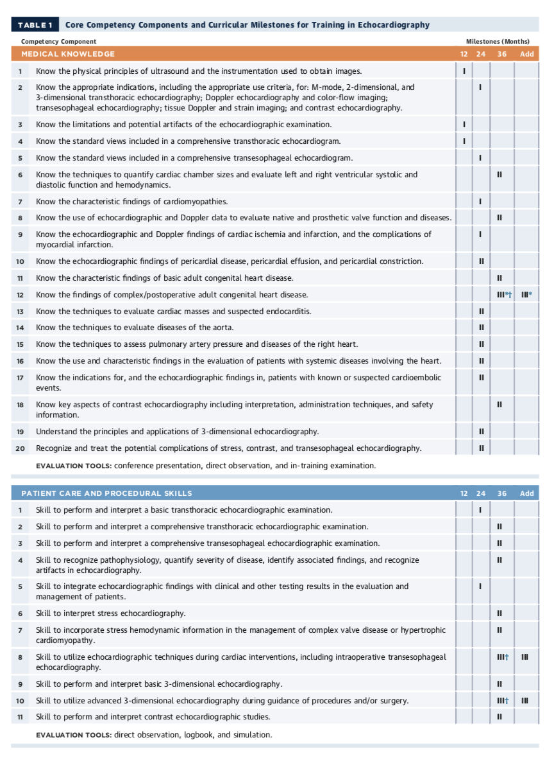

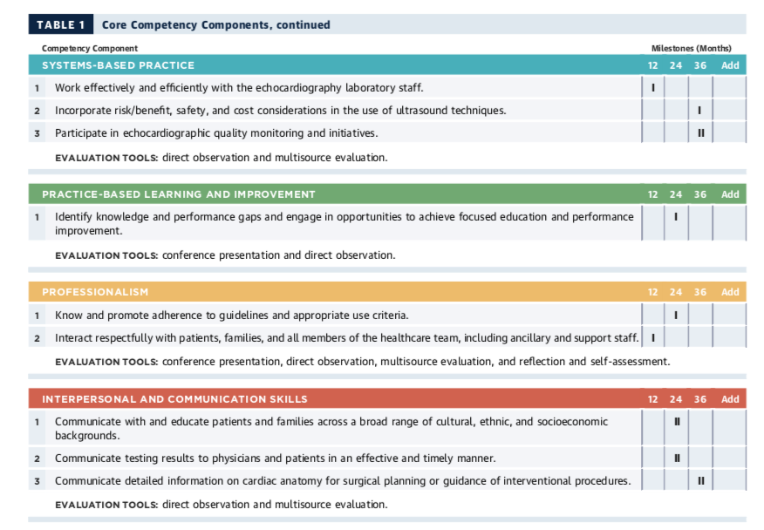

ACC 2015 Core Cardiovascular Training Statement (COCATS 4). J Am Coll Cardiol. 2015;65:1721-1906.

