Heart Failure Rotation:

General goals: The goal of the heart failure rotation is to train fellows in the care of patients with advanced heart failure with both reduced and preserved ejection fraction due to multiple etiologies. Fellows should learn the interpretation and application of invasive hemodynamics and pharmacologic therapy for heart failure. Furthermore, fellows should be introduced to the management of patients with mechanical circulatory support and cardiac transplantation. Fellows will also be expected to interact professionally with patients, families, and all members of the heart failure team.

Objectives:
1st year fellow (1 month):
-Effectively complete history and physical exam, understanding relevance as well as limitations of findings in patients with heart failure.
-Identify signs of volume overload and hypoperfusion on physical exam.
-Execute diagnostic work up to identify etiology of new onset heart failure.
-Know and effectively utilize pharmacologic therapy for heart failure including indications, contraindications and mechanism of action.
-Integrate information from multiple diagnostic procedures in the diagnosis and management of patients with heart failure.
-Know indications and contraindications for vasoactive and inotropic medications and use effectively in advanced heart failure.
-Accurately interpret invasive hemodynamic measurements and understand implications for management, initially with supervision.

2nd year fellow (2 months): In addition to the above,
-Understand staging of heart failure and natural history of the condition.
-Review the pathophysiology of heart failure in detail and recognize the roles of neurohormonal activation and left ventricular remodeling.
-Integrate pathophysiology and management of heart failure with other systemic diseases, including renal failure.
-Discuss indications and contraindications for cardiac transplantation and mechanical circulatory support.
-Perform, interpret, and apply clinical reasoning to invasive hemodynamic monitoring, initially with supervision.
-Manage cardiac arrhythmias in patients with heart failure.
-Know indications and contraindications for implantable cardioverter-defibrillators and cardiac resynchronization therapy and effectively refer for device therapy as indicated.
-Understand fundamentals of left ventricular assist device management, initially with supervision.
-Demonstrate ability to have informative, compassionate discussions with heart failure patients regarding their illness and prognosis.
-Understand the role of palliative care and hospice in heart failure and refer patients as indicated.
-Engage in discussions with patients and families regarding patient’s condition and prognosis and utilize shared decision making for management.
-Complete COCATS level 1 training (total 2 months).

3rd year fellow: In addition to the above,
-Know pharmacology of and be able to effectively utilize immunosuppressive therapies and prophylaxis in patients with heart transplant.
-Identify clinical signs and symptoms of transplant rejection.
-Discuss indications, contraindications and interpretation of cardiopulmonary stress testing, and effectively apply to patient management.
-Effectively identify appropriate candidates for mechanical circulatory support (both as a bridge to transplant as well as destination therapy) and cardiac transplant.
-Be able to provide effective management of patients with advanced heart failure in both the inpatient and ambulatory settings.
-Actively participate in heart failure didactic sessions.
-Understand the role and clinical applications of genetics and biomarkers in heart failure, including strategies for prevention.
-Complete COCATS Level 2 training.

Attending responsibilities: (program specific)

Suggested reading:
Advanced Heart Failure and Cardiac Transplant; Michael J. Domanski, Mandeep R. Mehra, and Mark A. Pfeffer
Heart Failure: A Companion to Braunwald’s Heart Disease; G. Michael Felker and Douglas L. Mann
ACC/AHA Clinical Practice Guidelines for Heart Failure (https://www.acc.org/guidelines)

Evaluation of trainee: (program specific)

Evaluation of rotation: (program specific)

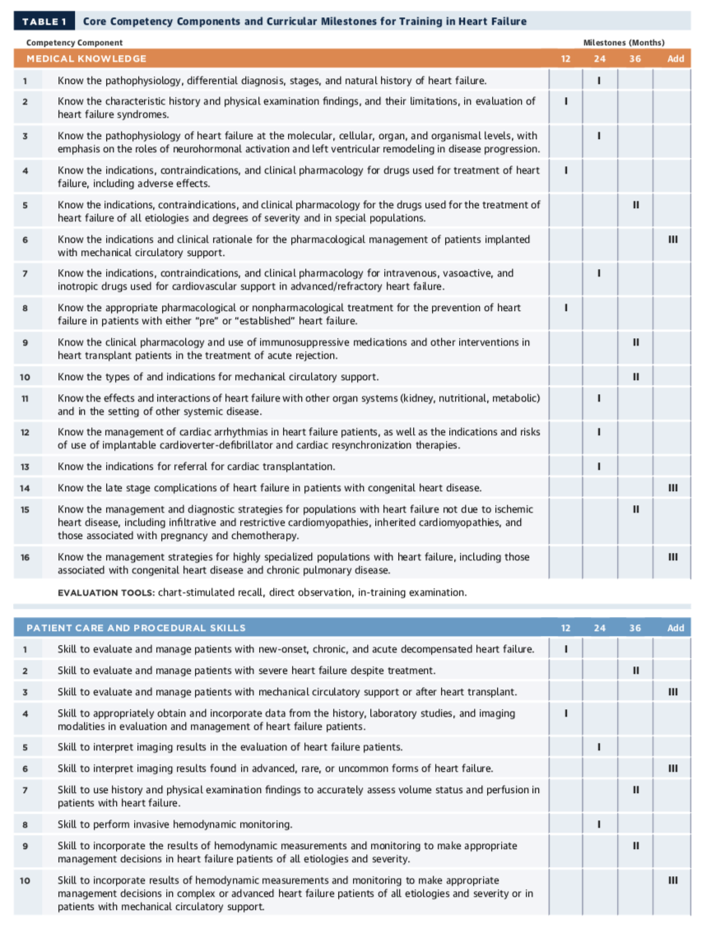

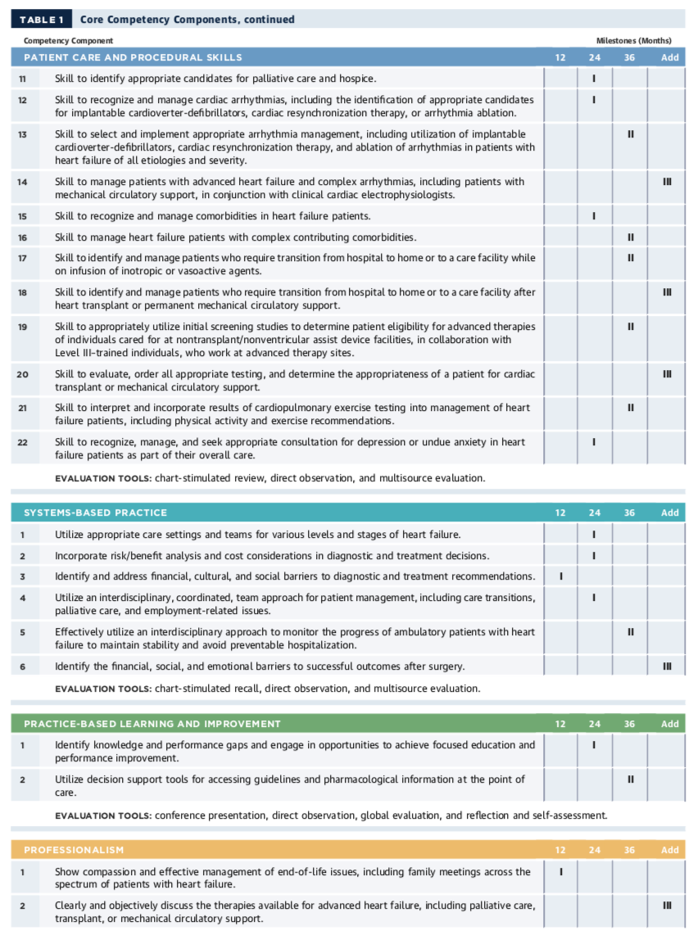

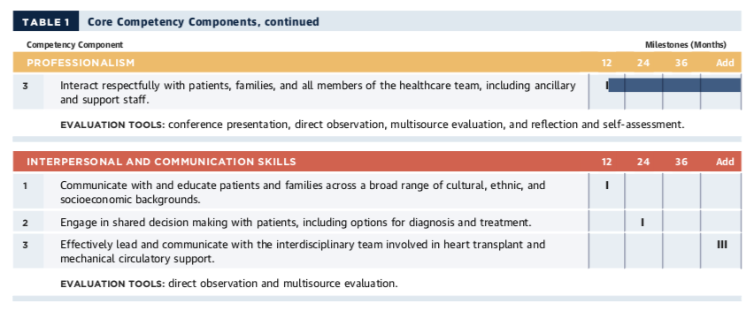

ACC 2015 Core Cardiovascular Training Statement (COCATS 4). J Am Coll Cardiol. 2015;65:1721-1906.

