Nuclear Cardiology Rotation:

General goals: The goal of the nuclear cardiology rotation is to train all fellows in the fundamentals of nuclear cardiology and exercise treadmill testing for application in the clinical management of cardiovascular patients. This includes exercise treadmill testing, single-photon emission computed tomography (SPECT) and/or positron emission tomography (PET), cardiac function assessment with gated SPECT and/or PET, and gated equilibrium radionuclide ventriculography. Fellows will be a part of the nuclear laboratory and work closely with the ordering providers as well as all of the laboratory staff. They will feel comfortable communicating study findings with the ordering providers when appropriate. They will be expected to interact respectfully with patients, families, and all members of the healthcare team.

Objectives:
1st year fellow (1-2 months):
-Identify indications and contraindications for exercise treadmill testing.
-Understand hemodynamic response to exercise.
-Conduct an exercise stress test including preparation, performance, monitoring, and interpretation.
-Describe indications for myocardial perfusion imaging and criteria for determining exercise versus pharmacologic stress testing.
-Apply Bayes Theorem to interpretation of stress testing results.
-Recognize mechanism of action, protocol for administration, and adverse effects of pharmacologic stress agents.
-Review protocols and tracers for SPECT imaging.
-Perform a focused history and physical pertaining to stress testing.
-Perform exercise and pharmacologic nuclear stress testing, including monitoring during the test.
-Recognize normal perfusion and wall motion.
-Identify high risk findings on myocardial perfusion imaging.
-Describe vascular territories associated with polar maps.
-Understand radiation biology and regulations for use of radioactive materials and ionizing radiation.
-Ideally perform 100 examinations in a 2 month period under the supervision of the laboratory director and/or designated faculty, nurses, and nuclear technicians to meet COCATS Level 1 requirements.

2nd/3rd year fellow (3-4 months): In addition to the above,
-Interpret perfusion imaging accurately (including artifacts and use of attenuation correction) and construct a formal report.
-Perform and interpret radionuclide ventriculography study.
-Apply principles of radiation safety and understand how to minimize radiation exposure.
-Recognize indications for PET imaging and use of PET tracers.
-Integrate stress testing results into a management plan for the patient.
-Describe indications for myocardial viability studies, protocols for conducting studies, and accurately interpret results.
-Define indications and interpret results of nuclear imaging in cardiac amyloidosis and cardiac sarcoidosis.
-Review indications for cardiopulmonary exercise testing.
-Review quality control issues, recognize artifacts, and interpret raw data.
-Work towards COCATS Level 2 (4-6 months) with minimum of 700 hours of work experience, including radiation safety, and at least 300 examinations.
-Apply computer methods for analysis of perfusion, functional data, ejection fraction, and regional wall motion measurements.
-Perform at least 30 complete studies (25 myocardial perfusion and 5 radionuclide ventriculography) under supervision including pre-test evaluation, radiopharmaceutical preparation, performance of test, administration of dosage, camera set up and calibration, data processing, interpretation of study, and preparation of report.
-Apply nuclear results to clinical correlation with cardiac catheterization or CT angiography for a minimum of 30 patients.
- For cardiac PET, direct patient experience with at least 40 studies (including myocardial perfusion and metabolism) is required.

Fellow responsibilities: (program specific)

Attending responsibilities: (program specific)

Suggested reading:
Braunwald’s Heart Disease, chapters on exercise stress testing, nuclear cardiology, and coronary blood flow and myocardial ischemia
American Society of Nuclear Cardiology guidelines, www. asnc.org
Handbook of Nuclear Cardiology; Gary Heller and Robert Hendel
Atlas of Nuclear Cardiology; Vasken Dilsizian and Jagat Narula

Evaluation of trainee: (program specific)

Evaluation of rotation: (program specific)

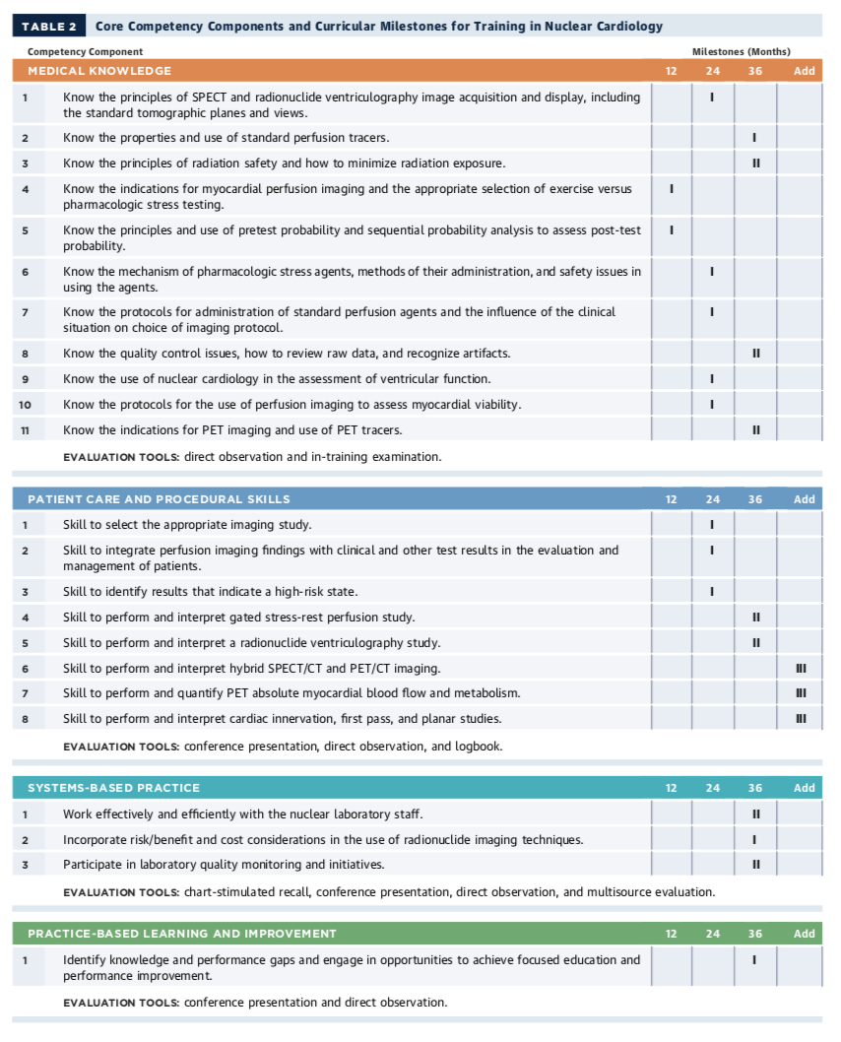

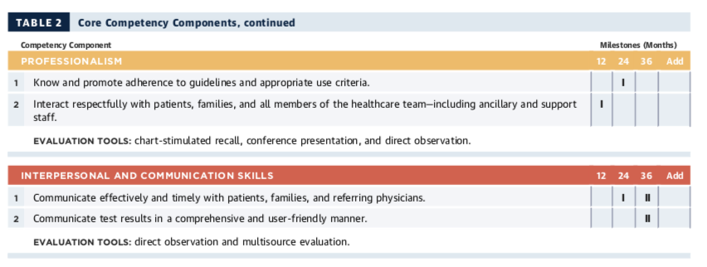

ACC 2015 Core Cardiovascular Training Statement (COCATS 4). J Am Coll Cardiol. 2015;65:1721-1906.

