Title: New onset symptomatic AF with RVR

Authors / Institution:

Author 1 | Lauren Basmadjian, MD
Senior Author | Nicolas Thibodeau-Jarry, MD, MMSC, Department of Medicine, Institut de cardiologie de Montréal
Institution | Institut de Cardiologie de Montréal/Montreal Heart Institute

Target audience:

Medical students
Medical clerks
Junior residents | X
Cardiology fellows in training | X
Cardiologists
Anesthesiologists
Cardiac Surgeons
Nursing | X

Learning Objectives:

- Students will develop a systematic approach to symptomatic new onset atrial fibrillation with rapid ventricular response
- Students will explain the rationale behind their therapeutic steps in managing the patient
- Students will properly identify the underlying rhythm and evaluate patient CAB’s
- Students will rule out indications for urgent cardioversion

- Students will assess for underlying causes / triggers for atrial fibrillation
  - Properly identify “secondary atrial fibrillation”
- Students will justify their choice for rhythm vs rate control and for starting anticoagulation
  - They should properly identify that this patient has contra-indications to rhythm control
- Establish an appropriate discharge plan for a patient with new onset atrial fibrillation

Checklist for optimal management:

- CAB’s and IV access
- Ensure that the patient is in an appropriately monitored area with telemetry
- Review the patient’s chart
- Ask for a 12-lead ECG, appropriate laboratory investigations and a CXR
- Identify new onset symptomatic atrial fibrillation with rapid ventricular response
- Rule out indications for urgent cardioversion
- Identify the underlying trigger for new onset atrial fibrillation in this patient
- Start appropriate treatment for the underlying trigger
- Establish an appropriate rate or rhythm control strategy
  - Identify contra-indications to rhythm control strategy
- Begin anticoagulation while justifying indications and ruling out contra-indications
- Re-assess response to chosen strategy
- Transfer the case to the staff doctor
- Establish the discharge plan upon prompting from the staff doctor

Environment:

- Simulation room should be made to look like a “shock room” in the ER
  - Can be a university or regional hospital
- The simulated “patient” should already be connected to a telemetry monitor displaying O2 sat, RR, BP, HR and the cardiac rhythm (AF with RVR)
  - High fidelity mannequin (or actor simulating the patient would alternatively work)
- A crash cart with defibrillator should be available
- The patient chart should be available
  - List of home medications
  - Medical history
  - History of current illness
  - Preliminary laboratory results
  - Requested tests done by ER physician
    - CXR (no report available will have to look at it on the computer)
    - ECG
    - Labs
- Additional labs upon student request

- The patient’s temperature will be provided upon student request
Actors:

- 1-2 residents
  - If proceeding with 2, they should work together as a team to efficiently manage the scenario
- 1 nurse
  - Actor with lines at times to prompt students into certain actions / help them along if stuck or struggling
- 1 staff doctor
  - Actor who will ask for the case to be transferred to them and will ask the resident to come up with a discharge plan and justify it

Material:

- Crash cart:
  - IV Lopressor, IV Cardizem, IV amiodarone
  - Propofol, versed, fentanyl
  - Defibrillator

Case History provided in the patient chart to the student:

60-year-old male who lived with his wife. Works as an investment advisor for a bank.

Reason for consult: Shortness of breath x 3 days

Past medical history: Ischemic cardiomyopathy with LVEF 40% on TTE from 2017, coronary artery disease with MI in 2016, DES x 2 on LAD (complete revascularization), hypertension and chronic obstructive pulmonary disease (FEV1: 55%, FEV1/FVC: 60%)

Allergies: Iodine

Home medications: ASA 80 mg die / Atorvastatin 40mg die / Perindopril-indapamide 4mg + 2.5mg die / Pantoprazole 40mg die / Spiriva 18mcg die / Ventolin PRN

Habits: Smoking d/c x 5 years / 10 alcoholic beverages per week / No drugs

ER note: Patient consulted for shortness of breath worsening x 72 hours. He was previously well with compensated NYHA 2 heart failure. He has not had any retrosternal chest pain but notes slight pleuritic discomfort on the right side. He has palpitations that started 14 hours ago. He feels a little dizzy when he stands up too quickly, but otherwise does not feel light-headed. He has never had syncope.
His baseline cough has increased, and his appetite is decreased compared to usual.

P.E.: Patient appears slightly diaphoretic and tachypneic, but not acutely unwell
Cardiac auscultation: Irregular HR, normal S1-S2, no murmur, JVP 3-4 cm above the angle of Louis
Pulmonary auscultation: Decreased air entry at lung bases R > L with crackles R > L
Abdomen: Normal
Extremities: Bilateral peripheral edema 1+

Impression/Plan:
New onset AF with RVR
Decompensated heart failure?
Trigger?
Labs: CBC, Cr, Na, K, blood gas, lactate, troponins, NTproBNP, Ddimer
ECG
CXR
Consult cardiology

Laboratory investigations:

In the chart:

Labs | Results | Previous | Reference
WBC | 13 | 8
Ne | 11 | 4
HB | 140 | 150
PLT | 225 | 270
Creat | 100 | 80
Urea | 8 | 6
Na | 140 | 142
K | 3.2 | 3.8
Lactates | 1.5 | NA
Venous PH | 7.36 | NA
Venous PCO2 | 43 | NA
Venous BIC | 23 | NA
Trops | 20 | 30 | < 14
NT-pro BNP | 800 | 700 | < 50: <450  50-75: 450-900  >75: <1800
Ddimer | 500 | NA | <500

Additional labs the student may request:

Labs | Results | Previous | Reference
Mg | 0.55 | 0.82
PO4 | 1.10 | 1.20
Ca | 2.24 | 2.26
TSH | 2.05 | 3
INR | 1.1 | 1.1
PTT | 33 | 28
HemoCx | pending | NA

Imaging:

12-lead ECG provided upon student request:

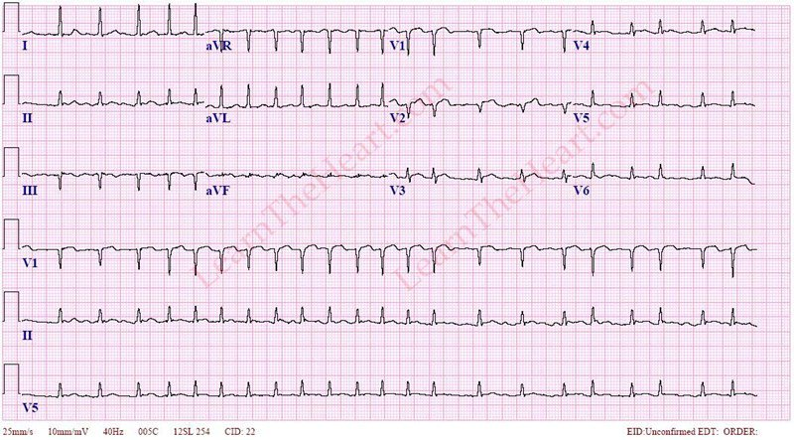

CXR open on computer:

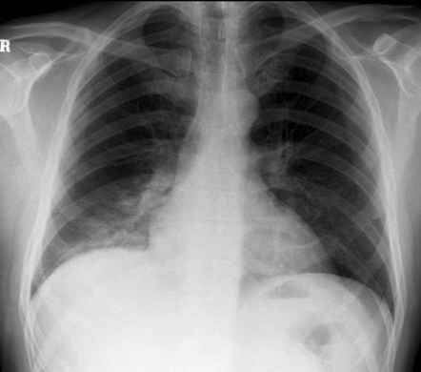
Notes for the instructor:

Summary of the scenario: A 60-year-old male presents with new onset atrial fibrillation with rapid ventricular response in the context of right lower lobe pneumonia. The patient will require management with antibiotics, volume repletion and appropriate anticoagulation. The atrial fibrillation will remain symptomatic despite adequate treatment of secondary cause and rate management will be required. A follow-up plan will also need to be established.

How the scenario should play out:

- Resident receives a page for a new cardiology consult for a patient with atrial fibrillation with rapid ventricular response by ER physician. He saw the patient quickly and was called to an unstable trauma case. He could use your help in managing this patient now.

- Information provided in patient chart should be read.
If the student asks to see the ECG/CXR/labs they should be oriented about where to find this information:
- ECG in chart
- Labs in chart
- CXR on computer and must be interpreted

- Vital signs provided on the telemetry monitor:
- BP: 110/60 / HR: 170-185 / RR: 28 / O2Sat: 93% on AA
- Telemetry clearly showing AF as underlying rhythm

***Students should recognise that the patient’s temperature is lacking from the vital signs provided on the monitor and ask for it***
- Rectal temperature: 38.6

At this point, after having “eye balled” the patient, and taken into account the vital signs, students should conclude that there is no indication for urgent direct current electrical cardioversion and should proceed with the clinical evaluation.
ECG should be requested

- Upon questioning the patient:
- Patient confirms information in the ER notes
  - 72 hours of shortness of breath with increased cough
  - No chest pain resembling angina
  - No RFs for PE
  - 14 hours of palpitations
  - Orthostatic hypotension
- Additional information provided if appropriate questions are asked:
  - No orthopnea or PND
  - No worsening pedal edema
  - He has never had palpitations before
  - Increased sputum production
  - His wife has a cold
  - He’s not sure if he has a fever, but he has had some shivering in the past 24 hours
  - No risk factors for pulmonary embolism
- Confirms past medical history and denies any history of stroke/ diabetes/ bleeding/ arrhythmia

***If the student did not previously ask for the patient’s body temperature, they should be prompted by the nurse to ask for it***
- Rectal temperature: 38.6

- Complete investigations and look at labs/ecg/CXR if not already done
- Suspicion of secondary AF should be clear
- Clinically, suspicion for pneumonia as the trigger should be high
  - Other trigger considerations (that are unlikely here include hyperthyroidism, pulmonary embolism, decompensated heart failure, acute coronary syndrome, alcohol/stimulant drugs…)
- Students should ask for: Mg, PO4, Ca, TSH, INR, PTT, hemocultures
- They may ask for a CRP, pro-calcitonin, liver enzymes, HbA1c, lipid profile.
- Should they ask for “unnecessary tests” such as CT PE study an excuse should be made about long wait times due to the trauma patient or that the patient must be prepared due to their iodine allergy.

- Treatment for pneumonia (the atrial fibrillation trigger) should be started
- Ceftriaxone 2g iv q24h + Azithromycin 500mg IV x 1 followed by 250mg IV x 4 days or PipTazo 3.375g IV q6h
- Bolus +/- IV perfusion
- Electrolyte disturbances should be corrected

- Patient remains symptomatic with complaint of palpitations and rate although slowed is still > 150 bpm.
- It would not be inappropriate for students to choose to observe the patient and not give anything specific for rate / rhythm control and simply continue treating the underlying cause
- As one of the objectives of this scenario is to evaluate rate/rhythm control, the student should be prompted to take this on.
  - For example:
    - Nurse asking “Shouldn’t we slow him down? He seems uncomfortable.”
    - Patient complaining persistently about on-going palpitations
  - If student insists that not necessary for XYZ reason, have the nurse ask what HR they should target.
  - When the student “later” re-evaluates the patient, have the HR be above that target and patient still symptomatic from palpitations.
- At this point, students should identify that rhythm control is contra-indicated in this patient.
  - > 12hours since onset of atrial fibrillation with CHADS 65 > 2 (CMP, HTN)
- Rate control should be tried, and the agent used should be Lopressor IV or an oral beta-blocker. Digoxin would be an appropriate alternative.
  - CCB are not the ideal choice given the patient is known for ischemic cardiomyopathy
- Patient will remain in AF but be more appropriately rate controlled at the end of the scenario

- Establish need for anticoagulation and appropriately initiate it

- Staff arrives
- Student transfers the case to the staff
- Staff asks student for discharge plan and F/U
  - Identify that new onset AF would benefit from trial of return to sinus rhythm
  - Identify that patient should receive 3 weeks ACO or TEE prior to DCEC
  - Discharge medications should include rate control agent and ACO
  - ASA should be stopped
  - TTE should be requested as in or outpatient
  - Student should recognize that patient will require long term ACO (beyond three weeks as CHADS 65 > 0)
  - Discussion of long-term rhythm control strategy could be discussed
    - CIs for certain agents
    - Limitations of long-term amiodarone in this young patient
    - Consideration for ablation / EP consult

Guide for debriefing:

Start by asking participant(s) to describe their experience.
- What did they feel, what was challenging, what went well, what might they do differently next time?
- If there were other residents observing the simulation, they may also make remarks after the resident(s) who directly partook in the simulation is(are) done speaking.

They will have already summarized the case and management to the “staff doctor”, so this portion of usual debriefing can be skipped.

Discuss the approach to the acute management of AF (see APPENDIX 1 for CCS recommendations)

Step 1:
Identify “primary” vs “secondary” AF particularly in the ER setting, highlighting that primary AF is rarely unstable.
- Discuss the possible causes of secondary AF.

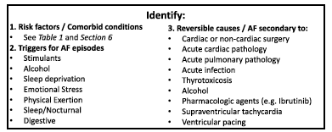

- Discuss the importance of initiating treatment of trigger if identified

Step 2:
Determine hemodynamic stability and identify indications for immediate cardioversion while highlighting the fact that primary AF is rarely unstable.
- Hypotension
- ACS
- Pulmonary edema
Again, emphasize that it is important to properly assess whether AF is causing the above adverse effects or whether there is an underlying process leading to the hemodynamic instability.

May discuss how to do carvioversion if desired and suggest sedation agents.
ACLS algorithm for tachycardia is proved for this purpose (see APPENDIX 2)

Step 3:
Determine the arrhythmia management strategy; rate vs rhythm (see APPENDIX 3 for CCS suggested approach).

Discuss options for rate / rhythm control in the acute setting.
- IV or oral options are both valid
- If giving IV, remember to co-administer an oral agent to avoid rebound tachycardia.
- Remind students that amiodarone has the potential to cardiovert and should therefore be avoided if contra-indications are present
- Target HR recommended < 100 bpm is acute setting.
  - No target for acutely ill patients with “secondary AF”

Discuss growing evidence that for new onset AF, an early rhythm control strategy is likely preferable.
- For stable patients who are eligible for cardioversion immediately this may be the preferred strategy
Discuss contra-indications/cautions to certain classes of anti-arrhythmic agents.
- CAD
- CMP
- Age related concerns with long-term use of amiodarone

Step 4:

Determine the need for anticoagulation and timing of initiation (see APPENDIX 4 for CHADS65 and CHADSVASC algorithm).
Discuss ACO options (see APPENDIX 5).
Discuss bleeding risk/CIs to ACO.

APPENDIX 1: CCS AF Recommendations

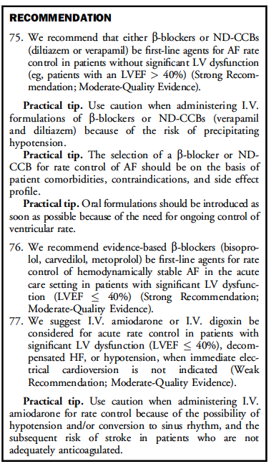
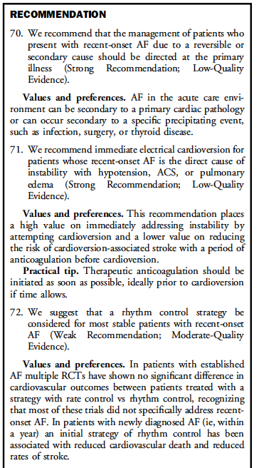

APPENDIX 2: ACLS Tachycardia Algorithm

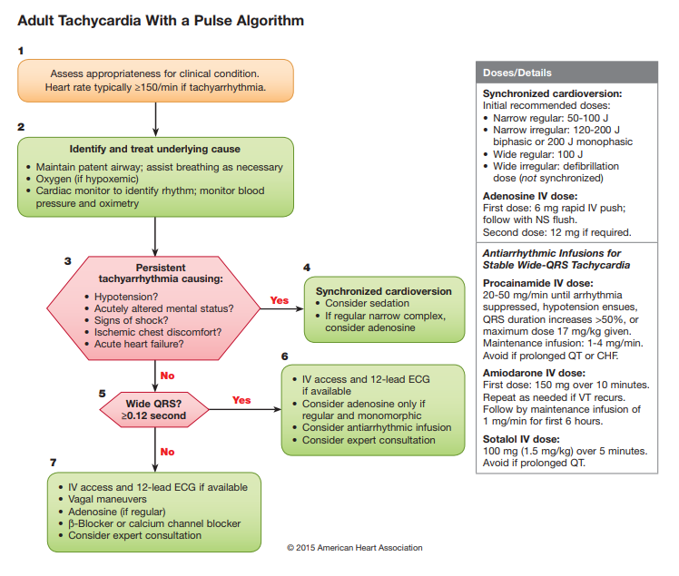

APPENDIX 3: Rhythm control in the acute setting

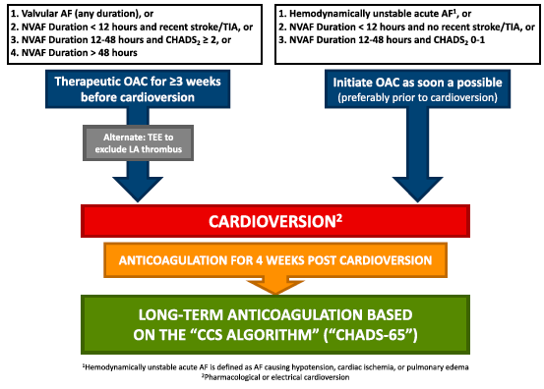

APPENDIX 4: CHADS 65/CHA₂DS₂VASC
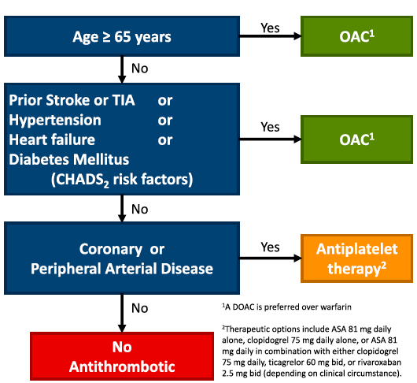

APPENDIX 5: ACO options and dosing regimens

