Title: Anterior STEMI with pulmonary edema

Authors and their affiliations

Author 1 | Jean-Bernard Breau, MD, PGY-5, Adult Cardiology, Université de Montréal
Senior Author | Nicolas Thibodeau-Jarry, MD, MMSC, Department of Medicine, Institut de cardiologie de Montréal
Institution | Institut de Cardiologie de Montréal/Montreal Heart Institute

Target Audience: Medical student, internal medicine junior residents and cardiology fellows

Learning and Assessment Objectives

Participants are expected to manage the clinical situation through the optimal path described below. The critical management actions are listed in the checklist.

Participants will be expected to discuss the pathophysiologic reasoning behind the course of treatment.

Critical Actions Checklist:

DONE CRITICAL ACTION
􀂆 CAB (circulation, airway, breathing)
􀂆 Telemetry monitoring
􀂆 Rapid patient history
􀂆 Rapid physical examination
􀂆 Identification of key exam findings
􀂆 Obtain labs, imaging (CXR), ECG
􀂆 Respiratory stabilization/Intubation
􀂆 Initiating medical management of STEMI
􀂆 Contacting appropriate consultants
􀂆 Activation of cardiac catheterization lab

Environment
- Simulation room set up: Emergency room monitored bed
- Manikin set up:
- High fidelity patient simulator
- Lines needed
- Props:
- Code blue cart
- Lab values (in appendix)
- Images (CXR)
- EKGs
- Distracters: none

Actors
- Nurse: facilitates scenario
- Consultants: supervising resident; interventional cardiologist
- Case Narrative: Part I

PATIENT: 54 year-old man, Max Lockhart
CC: Chest pain, shortness of breath

HPI
The following history is given by the resident in the Emergency Department, as pass-off to the resident from the cardiology consultation team:

This is a 54-year-old man with no prior medical history. He has a habit of smoking and social drinking. He started feeling some discomfort in the chest for about 30 minutes a day ago. Around 6 hours ago, he felt a stronger pain in the chest which has not resolved since. He finally called an ambulance when he started feeling nauseated and short of breath. We think he is having a myocardial infarct but we want your opinion before activating the cath lab team.

The rest of the symptoms and history are given only if asked for by the learners

The patient is uncomfortable and grimacing. He is visibly short of breath.

When prompted, he says he might have had a few episodes of exertional chest pains in the past few weeks. He denies any other symptom prior to yesterday. He denies cocaine use or use of any other stimulant. He works as a delivery man for a shipping company.

He says that the chest pain is usually 5 on 10 in severity and resolves after a few minutes of rest. However, the pain today is 10 on 10 in severity and is not getting better. The pain does not radiate anywhere and is not pleuretic. He is usually not short of breath, but has been feeling progressively more short of breath for the last couple of hours. He has not history of DVT or PE.

He denies any family history of CAD.

PMHx:
No hypertension, diabetes or dyslipidemia.

HOME MEDICATIONS  (not currently taking) | INPATIENT MEDICATIONS | ALLERGIES
None | None yet | None

PSHx:
None

SOCIAL Hx:
EtOH: Social drinker
Tobacco: Active smoker. 1 ppd for 30 years
Illicits: Denies
Occupation: Delivery man for shipping compagny
Additional: Married with 2 children

FAMILY Hx:
Both his parents are in good health.

ROS:
(+) chest pain, shortness of breath, nausea
(-) denies abdominal pain, cough, vomiting, diarrhea, fever/chills, headache, vision changes, lightheadedness, numbness/motor weakness.

PHYSICAL EXAM: learner must ask for specific findings if cannot be portrayed by mannequin and simulation technologist
GENERAL: A&Ox3, uncomfortable, diaphoretic.
HEENT: Unremarkable.
NECK: IJV > 6 cm AAL
PULM: Diffuse rales.
CV: S3 gallop, no murmurs.
ABD: Obese, soft, non-tender. BS present.
EXT: Warm, sweaty. Palpable pulses in all extremities.
NEURO: No focal deficits.

Temperature (ºC) | HR (bpm) | BP (mmHg) | RR (per min) | O₂ Sat
37.0 | 90 | 136/88 | 32 | 92% 10L NC
Cardiac telemetry: Sinus rhythm
ECG: A (initial ECG), B (control ECG)

LABS: See Appendix A

Amylase/Lipase Level | X | Comprehensive Metabolic Panel
Capillary/Venous Blood Gas | X | Hepatic Panel | X
Basic Metabolic Panel | X | Lactate/Cortisol Level
Cardiac Markers | X | Thyroid Panel
Coagulation Profile | X | Toxicology Screen
Complete Blood Count (CBC) | X | Urinalysis
CBC with differential |  | Urine HCG

IMAGES: See Appendix B

Angiogram |  | ECG | X
CT Scan, with contrast |  | MRI
CT Scan, without contrast |  | X-Ray | X
Echocardiogram |  | Ultrasound

Additional Images: None

CLINICAL PROGRESSION:
History and physical, supplemental O₂, monitor.

Learners must initially recognize and treat a STEMI with acute heart failure. Case will progress to worsening respiratory instability, requiring IV diuretics, intubation and urgent cath lab referral.

Case will continue until patient proceeds to cardiac catheterization.

*** If the Interventional Cardiologist is requested while the patient is in acute respiratory distress, consultants will advise to stabilize the patient before he can be brought to the catheterization lab.

*** If the Interventional Cardiologist is called once the patient is intubated, they will recommend activating cath lab for emergent ischemic evaluation.

*** If Aspirin, Clopidogrel/Ticagrelor, Statin and/or Heparin are administered, patient will continue to complain of chest pain and shortness of breath, with no change in vital signs or rhythm.

*** If nitrates are given, the chest pain will decrease but not resolve, vitals will change to:
Temperature (ºC) | HR (bpm) | BP (mmHg) | RR (per min) | O₂ Sat
37 | 95 | 118/86 | 30 | 93% 10L NC

*** If IV opiates are given, the chest pain will decrease but not resolve, vitals will change to:
Temperature (ºC) | HR (bpm) | BP (mmHg) | RR (per min) | O₂ Sat
37 | 95 | 118/86 | 32 | 93% 10L NC

*** If IV Furosemide is given, oxygen saturation will slightly improve, and VS will change as below:
Temperature (ºC) | HR (bpm) | BP (mmHg) | RR (per min) | O₂ Sat
37 | 95 | 118/86 | 30 | 96% 10L NC

*** If NIV is ordered, oxygen saturation will slightly improve, and VS will change as below, patient will still be unable to lay in the dorsal decubitus position:
Temperature (ºC) | HR (bpm) | BP (mmHg) | RR (per min) | O₂ Sat
37 | 90 | 118/86 | 28 | 96% 100% FiO2

*** If inotropes are administered, the patient will develop VT and lose their pulse.

*** If IV beta-blockade (5mg IV Lopressor) is given, the patients blood pressure will decline until the patient loses their pulse with a PEA arrest.

*** The scenario will progress (despite appropriate management) with worsening respiratory instability. Vitals will read:
Temperature (ºC) | HR (bpm) | BP (mmHg) | RR (per min) | O₂ Sat
37 | 100 | 118/98 | 40 | 86% 10L NC

*** Additional boluses of furosemide will not affect the respiratory distress. The patient will require emergent intubation.
*** If learners do not recognize acute respiratory failure, the RN will voice concern and call for intubation him/herself

*** After intubation, with etomidate, propofol or midazolam, cardiology will take the patient to the cath lab:
Temperature (ºC) | HR (bpm) | BP (mmHg) | RR (per min) | O₂ Sat
37 | 80 | 96/68 | 24  (vent) | 92%  On  100% FiO2

*** If bedside echocardiography is requested, the bedside ultrasound will show an ejection fraction of 30% with apical and anterior akinesis, normal right ventricular function, mild-to-moderare mitral regurgitation, no other significant valvular problem and no pericardial effusion.

Instructor Notes

- Tips to keep scenario flowing
- If need for further evaluation not recognized, nurse will make a suggestion for further evaluation.
- Nurse will prompt students to obtain control ECG if not requested.
- Nurse will prompt contacting consultants/RICU if not requested.
- Nurse will prompt learner to make management decision when O₂ Sat drops.

- Scenario programming
- Optimal management path
      - O₂/IV/monitor
      - History and physical examination
      - Requisite studies
        - Labs: BMP, CBC, cardiac markers, coagulation profile
        - Images: ECG, CXR
      - Medical Management of STEMI
        - ASA 325 mg
        - Clopidogrel 600 mg OR Prasugrel 60 mg OR Ticagrelor 180 mg
        - Heparin 60U/kg
      - Consulting Cardiology/Interventional Cardiology
      - Management of Acute heart failure
        - Furosemide IV

- Potential complications/errors path(s):
      - Failure to recognize STEMI
      - Failure to recognize need for intubation
      - Failure to contact appropriate consultants

Debriefing
- Method of debriefing: Group with teaching materials
- Didactic Material

X. Appendix A: Lab Values
Basic Metabolic Panel |  |  |  | Reference Range
Na⁺ |  | 139 |  | 135-147 mMol/L
K⁺ |  | 4.3 |  | 3.5-5.2 mMol/L
Cl⁻ |  | 101 |  | 95-107 mMol/L
HCO₃⁻ |  | 28 |  | 22-30 mMol/L
BUN |  | 13 |  | 7-20 mMol/L
Cr |  | 75 |  | 53-120 μMol/L
Glucose |  | 8.6 |  | 3.9-6.1 mMol/L
Mg ++ |  | 1.5 |  | 1.4-2.0 mEq/L
Ca ++ |  | 8.6 |  | 8.5-10.5 mg/dL
CBC w Differential |  |  |  | Reference Range
WBC |  | 7.5 |  | 4.5-11 th/cmm
Hgb |  | 14.6 |  | 12-16 gm/dl
Hct |  | 44.1 |  | 36-46%
MCV |  | 96 |  | 8—100 fl
PLT |  | 229 |  | 150-400 th/cmm
PMNs |  | 58 |  | 40-70%
Lymph |  | 30 |  | 22-44%
Eos |  | 3 |  | 0-8%
Cardiac Biomarkers |  |  |  | Reference Range
NT-BNP |  | 1600 |  | < 190
cTnT |  | 0.14 |  | <0.03 ng/mL
Coagulation Profile |  |  |  | Reference Range
PTT |  | 30 |  | 25-34 sec
INR |  | 1.1 |  | 0.8-1.2
Fibrinogen |  | 300 |  | 170 – 420 mg/dL
Liver Function Tests |  |  |  | Reference Range
Albumin | 4.0 |  | 3.3-5.0 gm/dl
ALT | 15 |  | 7-30 U/L
AST | 15 |  | 9-32 U/L
DBili | 7 |  | 2-7 μMol/L
TBili | 19 |  | 0-17 μMol/L
Alk Phos | 86 |  | 30-100 U/L
XI. Appendix B: Diagnostic Studies
Chest X-Ray

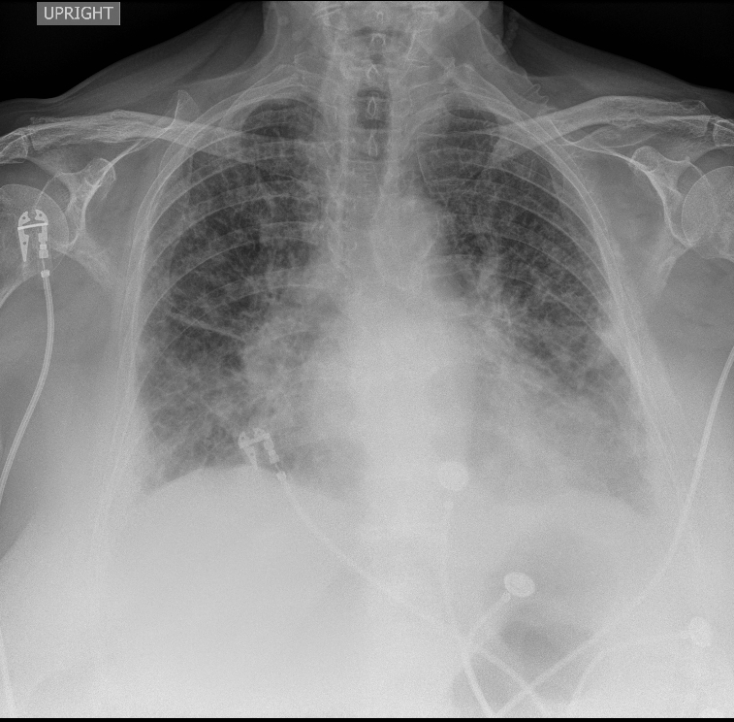

ECG A

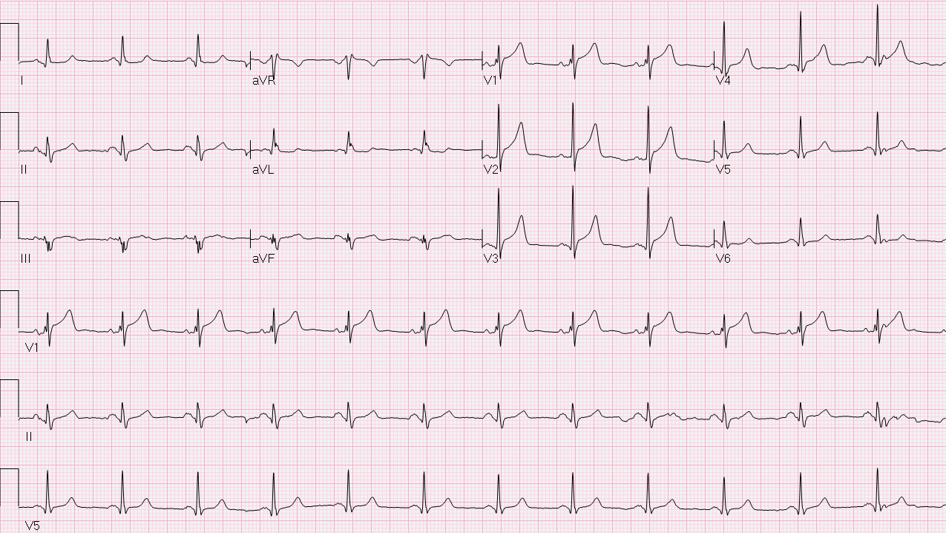

ECG B

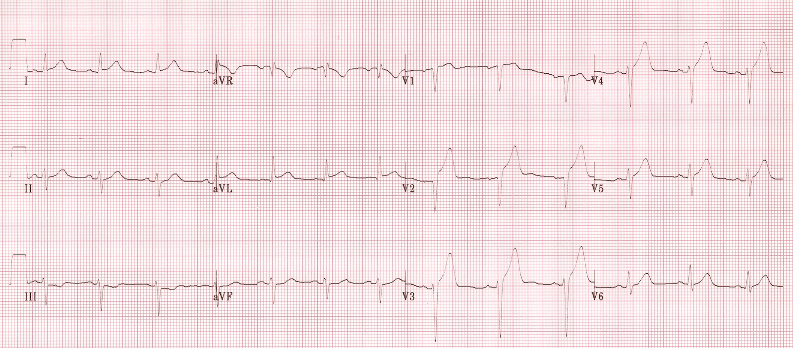
Debriefing Guide-STEMI K3
(Adapted from a debriefing guide used at the Massachusetts General Hospital, Boston, MA)

EKG Findings | Territory | Supplied By
V1-V2 | Septal-Anterior | Proximal-mid LAD
V5-V6 | Apical | Distal LAD, LCx, RCA
I, aVL | Lateral | Proximal LCx
II, III, aVF* | Inferior | RCA (90%), LCx
Acute Cornary Syndrome: Review and General Approach

STEMI – new left bundle branch block or ST elevation in 2 contiguous leads (>1mm in limbs leads, >2mm in precordial leads)

Medical Therapy of ACS

ACS Treatment | Dose | Comments
Aspirin | 325mg crushed, chewed, or rectal | Most important medication
ADP antagonist | Clopidogrel 300-600mg PO  Ticagrelor 180mg PO | Strongly indicated but institutionally dependent; talk to Cardiology
Heparin | Bolus: 60 U / kg  Infusion: 12 U / kg / hr | Consider risk of catastrophic bleed (previous ICH, recent stroke, history of massive GIB)
Beta Blocker | Metoprolol 5 mg IV  Metoprolol 6.25-25 mg Q6H PO | Avoid if bradycardia, hypotension, or high risk for cardiogenic shock
Oxygen | Keep sat >95% | Use only amount needed, no more
Nitrates | 0.4mg SL, ½ inch paste, or infusion | Titrate to symptom relief  Avoid if hypotension or RV MI
Morphine | 1-4mg IV Q4H PRN pain | Use if pain severe and refractory; don’t if hypotension or RV MI
Statin | Atorvastatin 80mg daily | Always

Right-sided leads Posterior leads (BMJ April 2002; 324(7341): 831-4)
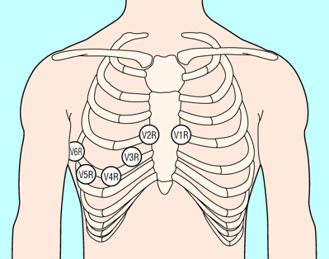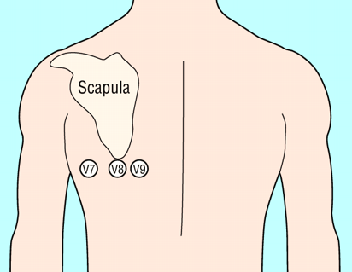
Inferior MI (involving leads II, III, aVF) – ST elevations III > II are suggestive of RCA occlusion (NEJM 2003; 348: 933-40; 30-50% of cases complicated by RV infarction [see below])

Right-Sided ECG Leads:
- Obtain right-sided ECG leads (V4R – V6R) to evaluate for infarction of right ventricle
- V4R ST elevations > 1mm most predictive of right ventricular infarct (88% Se, 78% Sp)
Posterior ECG Leads:
- Obtain V7-V9 leads when ST depressions in V1-V3 (to evaluate posterior wall of left ventricle)
- Obtain if elevated troponin with non-diagnostic ECG (to evaluate left circumflex – “silent”)

