**Case : Anterior STEMI with ventricular arrhythmia**

# I. Target Audience:

Medical students, Internal Medicine residents, Cardiology fellows

## II. **Authors and their affiliations**

|  |  |
| --- | --- |
| Author 1 | Eric Wong, MD, PGY-2, Internal Medicine, University of British Columbia |
| Author 2 | Alvan Buckley, MD, PGY-3, Internal Medicine, Memorial University of Newfoundland |
| Senior Author | Nicolas Thibodeau-Jarry, MD, MMSC, Department of Medicine, Institut de cardiologie de Montréal |

# III. Learning and Assessment Objectives:

Participants are expected to manage the clinical situation through the optimal pathway described below. The critical management actions are listed in the checklist.

Participants will be expected to discuss the pathophysiologic reasoning behind the clinical presentation and course of management.

**Critical Actions Checklist:**

DONE CRITICAL ACTION

􀂆 CAB (circulation, airway, breathing)

􀂆 Cardiac monitoring

􀂆 Rapid patient history

􀂆 Rapid physical examination

􀂆 Identification of key exam findings

􀂆 Obtain labs, imaging (CXR), EKG

􀂆 Initiating medical management of STEMI

􀂆 Appropriate identification and defibrillation of a ventricular arrhythmia

􀂆 Appropriate management of a ventricular arrhythmia with antiarrhythmics in the setting of ACS

􀂆 Contacting appropriate consultants

􀂆 Activation of cardiac catheterization lab

# IV. Environment:

1. Simulation room set up: Emergency room monitored bed
2. Mannequin set up:
   1. High fidelity patient simulator
   2. Single peripheral IV in place
3. Props:
   1. Code Blue cart
   2. Lab values (in appendix)
   3. Images (CXR)
   4. EKGs
4. Distractors: none

# V. Actors:

# 

# Nurse: facilitates scenario

# Consultants: supervising resident; interventional cardiologist

# VI. Case Narrative:

**ID:**  56 year-old male, Mr. Vince Troy

**CC:** Chest pain, shortness of breath

**HISTORY OF PRESENTING ILLNESS:**

**The following history is given by the resident in the Emergency Department, as pass-off to the resident from the cardiology consultation team:**

This is a 56-year-old man with hypertension and diabetes. He has a habit of smoking and social drinking. He started feeling intermittent chest discomfort a few days ago. Around 6 hours ago, he felt a stronger chest pain, which has not resolved since. He finally called an ambulance when he started feeling short of breath. We think he is having a myocardial infarct but we want your opinion before activating the cath lab team.

**The rest of the symptoms and history are given only if asked for by the learners:**

The patient is uncomfortable and grimacing. He is visibly short of breath.

When prompted, he says he may have had a few episodes of exertional chest pains in the past few weeks. He denies any other symptoms prior to yesterday. He denies cocaine use or use of any other stimulant. He works as a delivery man for a shipping company.

He says that the chest pain is usually 5 out of 10 in severity, and resolves after a few minutes of rest. However, the pain today is 10 out of 10 and is not getting better. The pain does not radiate anywhere and is not pleuritic. He is usually not short of breath, but has been feeling progressively more short of breath for the last couple of hours. He has no history of DVT or PE.

He denies any family history of CAD.

**PAST MEDICAL Hx:**

1. Hypertension
2. Type 2 diabetes (on medical therapy)
3. No previous surgeries

**ALLERGIES:**

None

**MEDICATIONS:**

1. Hydrochlorothiazide 25 mg PO daily
2. Metformin 500 mg PO BID

**SOCIAL Hx:**

EtOH: Social drinker

Tobacco: Active smoker. 1 ppd for 30 years

Illicits: Denies

Occupation: Delivery man for shipping company

Additional: Married with 2 children

**FAMILY Hx:**

Both his parents are in good health.

**REVIEW OF SYSTEMS:**

(+) chest pain, shortness of breath

(-) denies abdominal pain, cough, vomiting, diarrhea, fever/chills, headache, vision changes, lightheadedness, numbness/motor weakness

**PHYSICAL EXAM:** *learner must ask for specific findings if cannot be portrayed by mannequin and simulation technologist*

GENERAL: A&Ox3, uncomfortable, diaphoretic.

HEENT: Unremarkable.

NECK: IJV > 5 cm AAL

CV: S3 gallop, no murmurs.

PULM: Minimal crackles at the bases.

ABD: Obese, soft, non-tender. BS present.

EXT: Warm, sweaty. Palpable pulses in all extremities. Mild peripheral edema.

NEURO: No focal deficits.

|  |  |  |  |  |
| --- | --- | --- | --- | --- |
| **Temperature (oC)** | **HR (bpm)** | **BP (mmHg)** | **RR (per min)** | **O2 Sat** |
| 37.0 | 90 | 105/74 | 32 | 93% RA |
| ***Cardiac telemetry****: Sinus rhythm*  ***ECG****: A (initial ECG), B (control ECG)* | | | | |

**LABS:** See Appendix A

**IMAGES:** See Appendix B

**Additional Images:** None

**CLINICAL PROGRESSION:**

History and physical, supplemental O2, monitor, IV access

Learners must initially recognize and treat a STEMI. Case will progress to an episode of ventricular arrhythmia requiring CPR, defibrillation, initiation of antiarrhythmics and arrangement for an urgent coronary angiogram.

Case will continue until patient proceeds to cardiac catheterization.

*** If Aspirin, Clopidogrel/Ticagrelor, Statin and/or Heparin are administered, patient will continue to complain of chest pain and shortness of breath, with no change in vital signs or rhythm.

*** If oxygen is given, the oxygen saturation will increase to 100% and patient continues to complain of chest pain

*** If nitrates are given, the chest pain will decrease but not resolve, vitals will change to:

|  |  |  |  |  |
| --- | --- | --- | --- | --- |
| **Temperature (oC)** | **HR (bpm)** | **BP (mmHg)** | **RR (per min)** | **O2 Sat** |
| 37 | 95 | 98/66 | 30 | 93% RA |

*** If IV opiates (e.g. morphine) are given, the chest pain will decrease but not resolve, vitals will change to:

|  |  |  |  |  |
| --- | --- | --- | --- | --- |
| **Temperature (oC)** | **HR (bpm)** | **BP (mmHg)** | **RR (per min)** | **O2 Sat** |
| 37 | 95 | 94/62 | 26 | 91% RA |

*** If IV Furosemide is given, oxygen saturation will slightly improve, and vitals will change to:

|  |  |  |  |  |
| --- | --- | --- | --- | --- |
| **Temperature (oC)** | **HR (bpm)** | **BP (mmHg)** | **RR (per min)** | **O2 Sat** |
| 37 | 95 | 98/66 | 30 | 95% RA |

*** **If inotropes or vasopressors are administered**, the patient will develop VT and lose their pulse.

**\*\*\* If IV beta blocker** (e.g. Metoprolol 5 mg IV push) is given, the patient’s blood pressure will decline

*** The scenario will progress (despite appropriate management) with development of pulseless ventricular tachycardia. Vitals will read:

*** If learners do not recognize the arrhythmia, the RN will voice concern about the unusual rhythm and unresponsiveness

*** If learners ask for defibrillation the RN will begin placing the pads and turn on the defibrillator.

*** When learners order defibrillation, RN will ask at what which settings they would like. Ideally, shock will be delivered (synchronization not necessary) with 200 J (biphasic) and CPR should be restarted immediately after defibrillation for a full 2 minute cycle

*** After 1 full cycle of CPR the patient will continue to be pulseless and now in VF. CPR should be re-initiated and preparation for a second defibrillation.

*** If learners administer 300 mg of amiodarone or 50-100 mg of lidocaine, the subsequent rhythm check will result in a palpable pulse and good neurological recovery. Otherwise, pulseless VF will continue until an appropriate antiarrhythmic has been administered.

*\*\*\* If bedside echocardiography is requested, the bedside ultrasound will show an ejection fraction of 30% with apical and anterior akinesis, normal right ventricular function, and no pericardial effusion.*

# VII. Instructor Notes:

# Tips to keep scenario flowing

# If need for further evaluation not recognized, nurse will make a suggestion for further evaluation.

# Nurse will prompt learners to obtain control ECG if not requested.

# Nurse will prompt contacting consultants/RICU if not requested.

# Scenario programming

# Optimal management pathway

# O­2­/IV/monitor

# History and physical examination

# Requisite studies

# Labs: Cardiac biomarkers, CBC, Lytes, creatinine, coagulation profile, BNP (optional)

# Images: EKG, CXR

# Medical Management of STEMI

# ASA 160-325 mg

# Ticagrelor 180 mg or Clopidogrel 300-600 mg OR Prasugrel 60 mg

# Heparin 70-100 U/kg or LMWH 1mg/kg (e.g. Enoxaparin)

# Consulting Cardiology/Interventional Cardiology

# Management of ventricular arrhythmia

* + - 1. ACLS Algorithm (CPR, defibrillation, epinephrine)
      2. Medical therapy:
         1. IV Amiodarone 300 mg bolus
         2. IV Lidocaine 50-100 mg bolus

# Potential complications/errors path(s):

# Failure to recognize STEMI

# Failure to rapidly recognize need for CPR and defibrillation

# Failure to contact appropriate consultants

# VIII. Debriefing:

# Method of debriefing: group with teaching materials

# Didactic material

# IX. Appendix A: Lab Values:

|  |  |  |  |  |  |  |  |
| --- | --- | --- | --- | --- | --- | --- | --- |
| **Basic Metabolic Panel** | | | | **Reference Range** | | |  |
| Na+ | | 139 | | *135-147 mMol/L* | | |  |
| K+ | | 4.3 | | *3.5-5.2 mMol/L* | | |  |
| Cl- | | 101 | | *95-107 mMol/L* | | |  |
| HCO3- | | 28 | | *22-30 mMol/L* | | |  |
| BUN | | 9 | | *7-20 mMol/L* | | |  |
| Cr | | 75 | | *53-120 μMol/L* | | |  |
| Glucose | | 8.6 | | *3.9-6.1 mMol/L* | | |  |
| Mg ++ | | 1.5 | | *1.4-2.0 mEq/L* | | |  |
| Ca ++ | | 8.6 | | *8.5-10.5 mg/dL* | | |  |
| **CBC with Differential** | | | | **Reference Range** | | | |
| WBC | | 7.5 | | *4.5-11 th/cmm* | | | |
| Hgb | | 14.6 | | *12-16 gm/dl* | | | |
| Hct | | 44.1 | | *36-46%* | | | |
| MCV | | 96 | | *8—100 fl* | | | |
| PLT | | 229 | | *150-400 th/cmm* | | | |
| PMNs | | 58 | | *40-70%* | | | |
| Lymph | | 30 | | *22-44%* | | | |
| Eos | | 3 | | *0-8%* | | | |
| **Cardiac Biomarkers** | | | | **Reference Range** | | | |
| NT-BNP | | 1600 | | *< 190* | | | |
| cTnT | | 0.14 | | *<0.03 ng/mL* | | | |
| **Coagulation Profile** | | | | **Reference Range** | |  | |
| PTT | | 30 | | *25-34 sec* | |  | |
| INR | | 1.1 | | *0.8-1.2* | |  | |
| Fibrinogen | | 300 | | *170 – 420 mg/dL* | |  | |
| **Liver Function Tests** | | | | **Reference Range** | |  | |
| Albumin | 4.0 | | *3.3-5.0 gm/dl* | |  | | |
| ALT | 15 | | *7-30 U/L* | |  | | |
| AST | 15 | | *9-32 U/L* | |  | | |
| DBili | 7 | | *2-7 μMol/L* | |  | | |
| TBili | 19 | | *0-17 μMol/L* | |  | | |
| Alk Phos | 86 | | *30-100 U/L* | |  | | |
|  |  |  |  |  |  |  |  |

# X. Appendix B: Diagnostic Studies:

Chest X-Ray

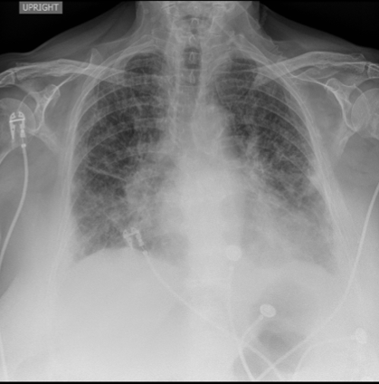

ECG A

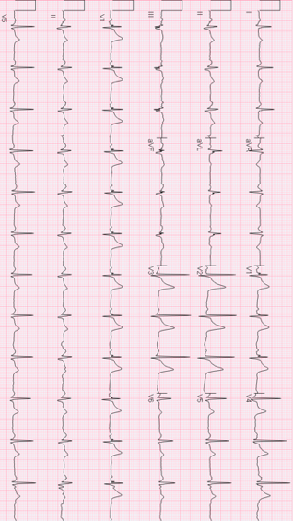

ECG B

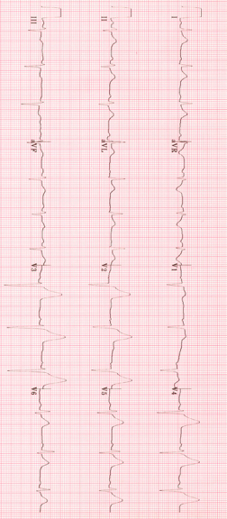

**Acute Coronary Syndrome: Review and General Approach**

**(Adapted from a debriefing guide used at the Massachusetts General Hospital, Boston, MA)**

|  |  |  |
| --- | --- | --- |
| **EKG Findings** | **Territory** | **Supplied By** |
| V1-V2 | Septal-Anterior | Proximal-mid LAD |
| V5-V6 | Apical | Distal LAD, LCx, RCA |
| I, aVL | Lateral | Proximal LCx |
| II, III, aVF* | Inferior | RCA (90%), LCx |

STEMI – new left bundle branch block or ST elevation in 2 contiguous leads (>1mm in limbs

leads, >2mm in precordial leads)

Medical Therapy of ACS

|  |  |  |
| --- | --- | --- |
| **ACS Treatment** | **Dose** | **Comments** |
| Aspirin | 325mg crushed, chewed, or rectal | Most important medication |
| ADP antagonist | Clopidogrel 300-600mg PO  Ticagrelor 180mg PO | Strongly indicated but institutionally dependent; talk to Cardiology |
| Heparin | Bolus: 60 U / kg  Infusion: 12 U / kg / hr | Consider risk of catastrophic bleed (previous ICH, recent stroke, history of massive GIB) |
| Beta Blocker | Metoprolol 5 mg IV  Metoprolol 6.25-25 mg Q6H PO | **Avoid if bradycardia, hypotension, or high risk for cardiogenic shock** |
| Oxygen | Keep sat >95% | Use only amount needed, no more |
| Nitrates | 0.4mg SL, ½ inch paste, or infusion | **Titrate to symptom relief**  **Avoid if hypotension or RV MI** |
| Morphine | 1-4mg IV Q4H PRN pain | **Use if pain severe and refractory; don’t if hypotension or RV MI** |
| Statin | Atorvastatin 80mg daily | Always |

Right-sided leads Posterior leads (*BMJ* April 2002; 324(7341): 831-4)

*Inferior MI (involving leads II, III, aVF) – ST elevations III > II are suggestive of RCA occlusion (NEJM 2003; 348: 933-40; 30-50% of cases complicated by RV infarction [see below])*

Right-Sided ECG Leads:

* Obtain right-sided ECG leads (V4R – V6R) to evaluate for infarction of right ventricle
* V4R ST elevations > 1mm most predictive of right ventricular infarct (88% Se, 78% Sp)

Posterior ECG Leads:

* Obtain V7-V9 leads when ST depressions in V1-V3 (to evaluate posterior wall of left ventricle)
* Obtain if elevated troponin with non-diagnostic ECG (to evaluate left circumflex – “silent”

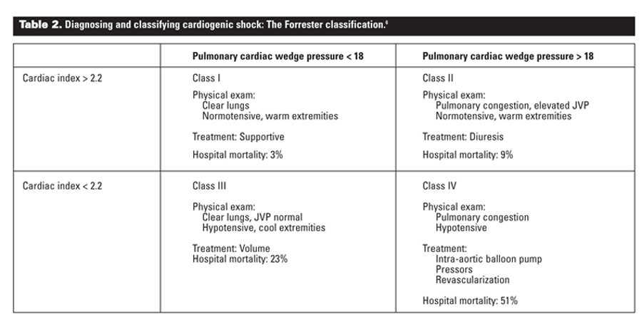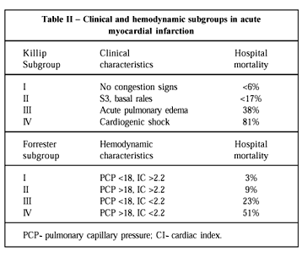

**Approach to Wide Complex Tachycardia (WCT)**:QRS > 120ms and ventricular rate > 100bpm

**Differential Diagnosis of WCT**

**Pre-excitation syndromes**

- SVT conducts an electrical impulse into the ventricles through an accessory conduction pathway (i.e. WPW, antidromic AVRT) in which electricity moves slowly through the ventricular myocytes rather than quickly along the His-Purkinje system

Review baseline ECG

**Supraventricular tachycardia (SVT) with aberrancy**

- AT, AF, AFlutter with conduction delay (RBBB, LBBB, IVCD); generally rate related or pre-existing

Review 12-lead ECG

Review baseline ECG

Use approach below to differentiate VT from non-VT

**Pacemaker-related tachycardia**

*1. PPM mediated:* Aberrant circuit is generated by the pacemaker (ventricular pacing conducts retrograde → atrial depolarization → sensed by pacemaker → V paced)

*2. PPM tracked:* SVT → sensed by pacemaker → V paced

Look at ECG (pacing spikes)

Trial magnet (switches mode to VOO or DOO)

**Ventricular Tachycardia (VT)**

*\*Treat all WCT as VT until proven otherwise (at least 80% of WCT in patients with ischemic or structural heart disease is VT)*

*-* Ectopic ventricular impulse spreads electrical activity slowly through the ventricular myocytes and produces a wide QRS

**Monomorphic**

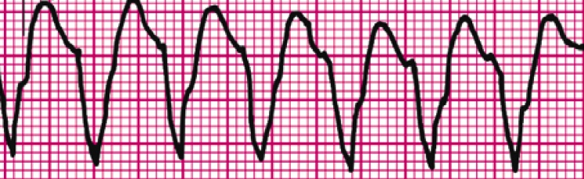

Review history

Evidence of impaired cardiac function?

Review 12-lead ECG

Use approach below to differentiate VT from non-VT

**Polymorphic**

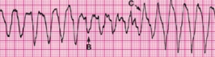

- Review ECG (QTc) and medications

***If Normal QTc:***

Ischemia

***If Prolonged QTc:***

Torsades

Differentiating VT from non-VT

1. Look at baseline ECG *(BBB at baseline? Pre-excitation? PVCs match WCT?)*
2. Review 12-lead EcG
   * Regular or irregular *(VT is very regular other than “warm-up” irregularity, SVT can be irregular)*
     + NW Axis? *(QRS down in I and aVF, suggests VT)*
     + AV dissociation? *(VT hallmark, no relation between P waves and QRS)*
     + Fusion/Capture beats? *(see below, diagnostic of VT)*
     + QRS duration *(VT more likely if QRS is RBBB with QRS >140ms, or LBBB with QRS >160ms)*
   * Precordial concordance? *(VT more likely if QRS complexes in V1-V6 are monophasic and monopolar (i.e. all upright or all inverted))*
   * Pacer spikes?

Capture beats (C): result from atrial depolarization that is able to normally conduct a narrow QRS and transiently interrupts the spread of electricity from the VT focus

Fusion beats (F): result from simultaneous conduction and blending of supraventricular beat and wide complex ventricular beat

**Principles of Acute Management**

* **Is there a pulse?** If no, proceed to ACLS VT/VF arrest algorithm, defibrillation (150-200J if biphasic, 360J if monophasic).
* **Stable or unstable?** If unstable with a pulse, proceed to synchronized DCCV.
  + ***Hemodynamically unstable or highly symptomatic***: prepare for synchronized DCCV with fentanyl/versed for sedation
    - Amiodarone 150mg IV followed by gtt at 1mg/min and/or Lidocaine 100mg IV followed by gtt at 1mg/min
      * *Note: Avoid Amiodarone in torsades de pointes: beta-blocking activity slows the HR and K+ channels, prolonging the QTc which promotes torsades de pointes*
      * *Note: If concern for WPW/accessory pathway, avoid Amiodarone (beta-blockade effect on AV node increases conduction down accessory pathway)*
  + ***Hemodynamically stable***: you have time to think about etiology
    - **VT?** Amiodarone 150mg IV followed by gtt at 1mg/min and/or Lidocaine 100mg IV followed by gtt at 1mg/min
    - **Torsades?** Put pads on patient for possible DCCV or over-drive pacing; Lidocaine; Isoproterenol (2-6mcg bolus followed by 2-20mcg/min) or Dopamine (starting at 300mcg/min); electrolyte repletion (Mg 2g boluses)
      * *Note: increased HR will shorten QTc, can abort Torsades/PMVT*
      * *Note: Avoid Amiodarone in torsades de pointes: beta-blocking activity slows the HR and K+ channels, prolonging the QTc which promotes torsades de pointes*
    - **PMVT with normal QTc?** Treat ischemia: activate catheterization lab, aspirin, statin, unfractionated heparin, beta blocker, Amiodarone
    - **Pacer-related?** Apply magnet
    - **Pre-excitation?** Procainamide 20-50mg/min until arrhythmia is controlled; stop if hypotension or QRS widens by 50% of its original width, or total of 17mg/kg is given, followed by 1-6mg/min infusion
      * *Note: Lidocaine or procainamide are preferred if WPW is possible as both drugs reduce accessory pathway conduction*
      * *Note: Avoid nodal agents (calcium channel blocker, beta blocker) in WPW with pre-excited AF*

