Title: Cardiogenic shock with pulmonary edema (“cold and wet”)

Authors and their affiliations

Author 1 | Kevin Tse, MD, PGY-6 Adult Cardiology, Université de Montréal
Senior Author | Nicolas Thibodeau-Jarry, MD, MMSC, Department of Medicine, Institut de cardiologie de Montréal
Institution | Institut de Cardiologie de Montréal/Montreal Heart Institute

Target Audience: Internal Medicine Junior Residents (PGY-2)

Learning and Assessment Objectives

Participants are expected to execute the optimal management path as defined below and through the critical actions checklist as well as discuss the pathophysiologic reasoning behind a certain course of treatment. Debriefing sessions may be used to allow each participant to reflect upon the team dynamics and to identify future technical and behavioral goals.

Critical Actions Checklist:

DONE CRITICAL ACTION
□ CAB (circulation, airway, breathing)
􀂆 Telemetry monitoring
􀂆 Rapid patient history
􀂆 Rapid physical examination
□ Identification of key exam findings
􀂆 IV Access + invasive hemodynamic monitoring
􀂆 Recognize and appropriately treat cardiogenic shock, including eventual need for mechanical support
􀂆 Obtain labs, imaging (CXR), ECG
□ Recognize progressive respiratory failure requiring intubation

Environment
- Simulation room set up: ER “crash room”
- Manikin set up:
- High fidelity patient simulator
- Lines needed
- Props:
- Code blue cart
- Lab values
- Images (CXR)
- EKGs
- Echo report
- Distracters: none

Actors
- Nurse: facilitate scenario
- Consultants: Supervising Resident; Cardiology; Interventional Cardiologists
- Case Narrative: Part I

SCENARIO

You are the in-house resident on call overnight and are called for a cardiology consultation to “r/o HF”. The nurse has asked you to see the patient urgently because he looks “unwell”.

You rapidly read through the chart and get the sense of a 36M patient who had recovered from a “cold” two weeks ago, but has been progressively getting more and more short of breath for the past week, associated with leg swelling. He also had a presyncopal episode at home, which prompted his girlfriend to call 911.

On arrival, the patient’s vital signs were:
HR: 110bpm
BP: 100/60
Sat: 88% on room air, RR 22

He was started on oxygen and given IV Lasix for suspected heart failure with a request for an echocardiogram in the morning.

HOME MEDICATIONS  (not currently taking) | INPATIENT MEDICATIONS | ALLERGIES
nil | Lasix 20mg IV bid | Penicillin (rash)

Past medical hx: nil
Habits: Non-tobacco smoker, social drinker, occasional marijuana.

CURRENT STATE
“I feel unwell, lightheaded”

REVIEW OF SYSTEMS/HPI:
Neuro: drowsy, but arousable. No headache or other neurological complaints
Resp: +cough, white sputum
Cardio: vague chest discomfort. no palpitations. +orthopnea/PND
GI/GU: nil, not much urinary output.
ID: nil
All other questions on HPI (travel, infectious hx, B-symptoms, etc) are negative.

Temperature (ºC) | HR (bpm) | BP (mmHg) | RR (per min) | O₂ Sat
37.0 | 110 | 75/45 | 24 | 86% 5L NC
Cardiac telemetry: SR with short runs of NSVT

PHYSICAL EXAM
Looks unwell, dyspneic
Circulation: faint pulses, cold extremities, moist to touch
A: protecting airway
B: dyspneic/tachypneic
Glucose (if asked) normal 6.4

Neuro: Drowsy but arousable. GCS 13. Disoriented to time and space but able to answer questions. No focal neuro deficits, but weakly squeezes hands and needs ++ prompting to move feet.
CVS: Normal S1 S2, audible S3 along parasternal border. No murmur. JVP elevated to jaw angle at 45 degrees
Resp: crackles throughout all lung fields, no wheezing, no stridor
GI: soft abdomen, nil acute
LE: slight pedal edema 1+. Pulses very faint.

ASSESSMENT AND MANAGEMENT (2 parts)

Part 1

- Learner will have need to recognize an acutely ill patient, with peripheral signs of cardiogenic shock with pulmonary edema. They must be able to initiate appropriate pharmacological treatment for hemodynamic stabilization.
- Case will evolve towards cardiac arrest if no rapid hemodynamic stabilization is achieved.

- Case will evolve towards progressive respiratory distress requiring intubation regardless of prior interventions.

History and physical, IV access, supplemental O₂, monitor
***Invasive hemodynamic monitoring with arterial line and foley catheter for urinary output should be obtained. Nurse should prompt if not part of immediate action plan
Flow according to interventions:

Hemodynamics

*** If fluids are given, vitals will change to:
Temperature (ºC) | HR (bpm) | BP (mmHg) | RR (per min) | O₂ Sat
37 | 120 | 75/45 | 28 | 86% via NC

*** If beta-blockade, calcium channel blockers are given, nurse will prompt: “Doc, the patient’s BP is x/x (low).”
If insists, 2nd prompt: “Doc I don’t think that’s a good idea”
If administered, patient will become semi-responsive with VS below
Temperature (ºC) | HR (bpm) | BP (mmHg) | RR (per min) | O₂ Sat
37 | 90 | 50/30 | 26 | 92% via NL

*** If nitrates are given, nurse will prompt: “Doc, the patient’s BP is x/x (low).”
If administered, patient will become semi-responsive with VS below
Temperature (ºC) | HR (bpm) | BP (mmHg) | RR (per min) | O₂ Sat
37 | 120 | Drop by 18/6 (10) | 26 | unchanged

*** If IV Furosemide is given, oxygen saturation will slightly improve, and VS will change as below:
Temperature (ºC) | HR (bpm) | BP (mmHg) | RR (per min) | O₂ Sat
37 | 100 | Drop by 5/x | Decrease by 4 | 90% via NC

*** If Vasopressors are given, dose will need to be specified (see Appendix E)
If participant doesn’t know, nurse prompt: “I’ll just start at usual dose of xxxxx, is that ok?”
Also: “What BP am I targeting”
Temperature (ºC) | HR (bpm) | BP (mmHg) | RR (per min) | O₂ Sat
37 | 120 | Increase by 10/x | unchanged | unchanged
Any further increase in dose will have no effect on VS

*** If Inotropes are given, dose will need to be specified (see Appendix E)
If participant doesn’t know, nurse prompt: “I’ll just start at usual dose of xxxxx, is that ok?”
If administered with vasopressors on board:
Temperature (ºC) | HR (bpm) | BP (mmHg) | RR (per min) | O₂ Sat
37 | 100 | 105/45 (60) | 22 | unchanged
If administered without vasopressors:
Temperature (ºC) | HR (bpm) | BP (mmHg) | RR (per min) | O₂ Sat
37 | 100 | Drop by 9/3 (5) | 22 | unchanged
With each incremental dose increase, MAP will increase by 5

** vital sign changes are ballpark, and can obviously be modified, especially in context of multiple simultaneous interventions**

**If BP ever drops below 50/x with any combination of interventions, patient has VT arrest run ACLS for 1 cycle of shock/epi then ROSC.

Oxygenation

*** If increased fiO2 is used, vital signs will change to:
Temperature (ºC) | HR (bpm) | BP (mmHg) | RR (per min) | O₂ Sat
37 | 100 | unchanged | 24 | 88% via 100%

*** If NiV is used, vital signs will change to:
Temperature (ºC) | HR (bpm) | BP (mmHg) | RR (per min) | O₂ Sat
37 | 100 | unchanged | 24 | 90% via 100%
Patient will subsequently get agitated and try to remove the mask due to his lower GCS
Nurse prompt: “Doc, the patient is not tolerating BiPaP very well, and his sat keeps on dropping. Is there anything else we could do?”

*** if intubation is asked for, vital signs will change to:
Temperature (ºC) | HR (bpm) | BP (mmHg) | RR (per min) | O₂ Sat
37 | 100 | unchanged | 20 | 98% on fiO2 50%
If asked for, etCO2 will be 28mmHg (normal ~35mmHg)

***If Swan-Ganz inserted, initial readings will be as follow:
C.O  C.I | 3.0  1.6 | C.O: 4-7 L/min  C.I: 2.0-4.2 L/min/m2
SVR | 2200 | 700-1600 dyne-sec-cm-5
CVP | 17 | 1-5 mmHg
PCWP | 22 | 4-12 mmHg
PVR | 160 | 30-120 dyne-sec-cm-5

CONSULTANTS
Interventional cardiologist on call:
If request for cath lab for suspected ACS: “I don’t see any changes on EKG suggestive of STEMI. No indication for cath lab at this time.”
If no appropriate meds started prior to call: “Have you considered starting any vasopressors?”

If specific request for mechanical support (IABP, Impella): “Try to stabilize the patient with meds first, call me back in an hour or two if things aren’t improving…”

ICU:
The ICU resident tells you there is no bed at the moment. She asks you to stabilize the patient until she can find a bed. Suggests vasopressors and inotropes, if not yet started.

Paraclinical exams:

Labs: Appendix A
EKG: Appendix B
CXR: Appendix C
Echo: Appendix D
Medication doses: Appendix E

Part 1 ends when the patient is intubated and inotropes and vasopressors have been strated. The nurse tells you there is a bed in the ICU and the patient will be transferred there.

Part 2

“Two hours later, the ICU team is busy managing a code and ask you to reevaluate the patient, who is not improving.

The patient’s vital signs are as follows

Temperature (ºC) | HR (bpm) | BP (mmHg) | RR (per min) | O₂ Sat
37 | 100 | 90/45 (60) | 16 | 96% on FiO2 50%

Minimal urine output
Lactate: 7 mmol/L
Remains cool and clammy

Currently on
Levophed 30mcg/min
Dobutamine 7.5 mcg/kg/min
Epinephrine 1.5mcg/kg/min

What would be your next step?”
- Learner must recognize persistent/refractory cardiogenic shock despite intensive medical management and should think about alternative supports methods such as mechanical devices.

***Any further dose increase or non-interventional management will have no effect on vital signs.
***If indecision, nurse will suggest: “Should we start thinking of non-pharmacological interventions?”

**SCENARIO ENDS ONCE PARTICIPANT CALLS CATH LAB FOR INVASIVE HEMODYNAMIC SUPPORT**

Instructor Notes

- Tips to keep scenario flowing
- If need for further evaluation not recognized, nurse will make a suggestion for further evaluation.
- Nurse will prompt students to obtain baseline TESTS if not requested.
- Nurse will prompt contacting consultants/RICU if not requested.

- Scenario programming
- Optimal management path
      - O₂/IV/monitor
      - History and physical examination
      - Requisite studies
        - Labs: BNP, CBC, cardiac markers, coagulation profile
        - Images: ECG, CXR
      - Medical Management of cardiogenic shock with pulmonary edema (“cold and wet”)
      - Consulting for evaluation for mechanical support

- Potential complications/errors path(s):
      - Failure to recognize cardiogenic shock (as opposed to other causes)
      - Failure to recognize worsening hypoxemia despite non-invasive attempts at oxygenation
      - Administration of negative inotropes in the setting of cardiogenic shock
      - Administration of vasopressors without inotropes

Debriefing
- Method of debriefing: Group with teaching materials
- Didactic Material

Appendix A: Labs

Part 1

Na⁺ |  | 139 |  | 135-147 mMol/L
K⁺ |  | 3.5 |  | 3.5-5.2 mMol/L
Cl⁻ |  | 97 |  | 95-107 mMol/L
HCO₃⁻ |  | 16 |  | 22-30 mMol/L
BUN |  | 22 |  | 7-20 mMol/L
Cr |  | 140 |  | 53-120 μMol/L
Glucose |  | 8.6 |  | 3.9-6.1 mMol/L
Mg ++ |  | 1.2 |  | 1.4-2.0 mEq/L
Ca ++ |  | 8.6 |  | 8.5-10.5 mg/dL
CBC w Differential |  |  |  | Reference Range
WBC |  | 14.7 |  | 4.5-11 th/cmm
Hgb |  | 12.6 |  | 12-16 gm/dl
Hct |  | 38.2 |  | 36-46%
MCV |  | 101 |  | 8—100 fl
PLT |  | 99 |  | 150-400 th/cmm
PMNs |  | 58 |  | 40-70%
Lymph |  | 30 |  | 22-44%
Eos |  | 3 |  | 0-8%
Cardiac Biomarkers |  |  |  | Reference Range
NT-BNP |  | 8674 |  | < 190
cTnT  cTnT #2 |  | 0.10  0.11 |  | <0.03 ng/mL
Coagulation Profile |  |  |  | Reference Range
PTT |  | 28 |  | 25-34 sec
INR |  | 1.8 |  | 0.8-1.2
Fibrinogen |  | 300 |  | 170 – 420 mg/dL
Liver Function Tests |  |  |  | Reference Range
Albumin | 2.1 |  | 3.3-5.0 gm/dl
ALT | 400 |  | 7-30 U/L
AST | 452 |  | 9-32 U/L
DBili | 20 |  | 2-7 μMol/L
TBili | 30 |  | 0-17 μMol/L
Alk Phos | 86 |  | 30-100 U/L

Blood gas analysis |  |  | Reference Range
pH | 7.2 | 7.35-7.45
PCO2 | 26 | 35-45 mmHg
PO2 | 70 | 75-100mmHg
HCO3- | 16 | 22-26 meq/L
Lactate | 5 | 0-2 mmol/L

Part 2

Na⁺ |  | 131 |  | 135-147 mMol/L
K⁺ |  | 5.3 |  | 3.5-5.2 mMol/L
Cl⁻ |  | 92 |  | 95-107 mMol/L
HCO₃⁻ |  | 9 |  | 22-30 mMol/L
BUN |  | 30 |  | 7-20 mMol/L
Cr |  | 190 |  | 53-120 μMol/L
Glucose |  | 12.2 |  | 3.9-6.1 mMol/L
Mg ++ |  | 1.9 |  | 1.4-2.0 mEq/L
Ca ++ |  | 7.0 |  | 8.5-10.5 mg/dL
CBC w Differential |  |  |  | Reference Range
WBC |  | 15.1 |  | 4.5-11 th/cmm
Hgb |  | 11.0 |  | 12-16 gm/dl
Hct |  | 36.2 |  | 36-46%
MCV |  | 101 |  | 8—100 fl
PLT |  | 87 |  | 150-400 th/cmm
PMNs |  | 64 |  | 40-70%
Lymph |  | 30 |  | 22-44%
Eos |  | 3 |  | 0-8%
Cardiac Biomarkers |  |  |  | Reference Range
NT-BNP |  | 22564 |  | < 190
cTn |  | 0.30 |  | <0.03 ng/mL
Coagulation Profile |  |  |  | Reference Range
PTT |  | 28 |  | 25-34 sec
INR |  | 2.3 |  | 0.8-1.2
Fibrinogen |  | 460 |  | 170 – 420 mg/dL
Liver Function Tests |  |  |  | Reference Range
Albumin | 1.6 |  | 3.3-5.0 gm/dl
ALT | 1204 |  | 7-30 U/L
AST | 876 |  | 9-32 U/L
DBili | 36 |  | 2-7 μMol/L
TBili | 52 |  | 0-17 μMol/L
Alk Phos | 139 |  | 30-100 U/L

Blood gas analysis |  |  | Reference Range
pH | 6.9 | 7.35-7.45
PCO2 | 20 | 35-45 mmHg
PO2 | 75 | 75-100mmHg
HCO3- | 9 | 22-26 meq/L
Lactate | 8.6 | 0-2 mmol/L

Appendix B: EKG (no change part 1 and 2)
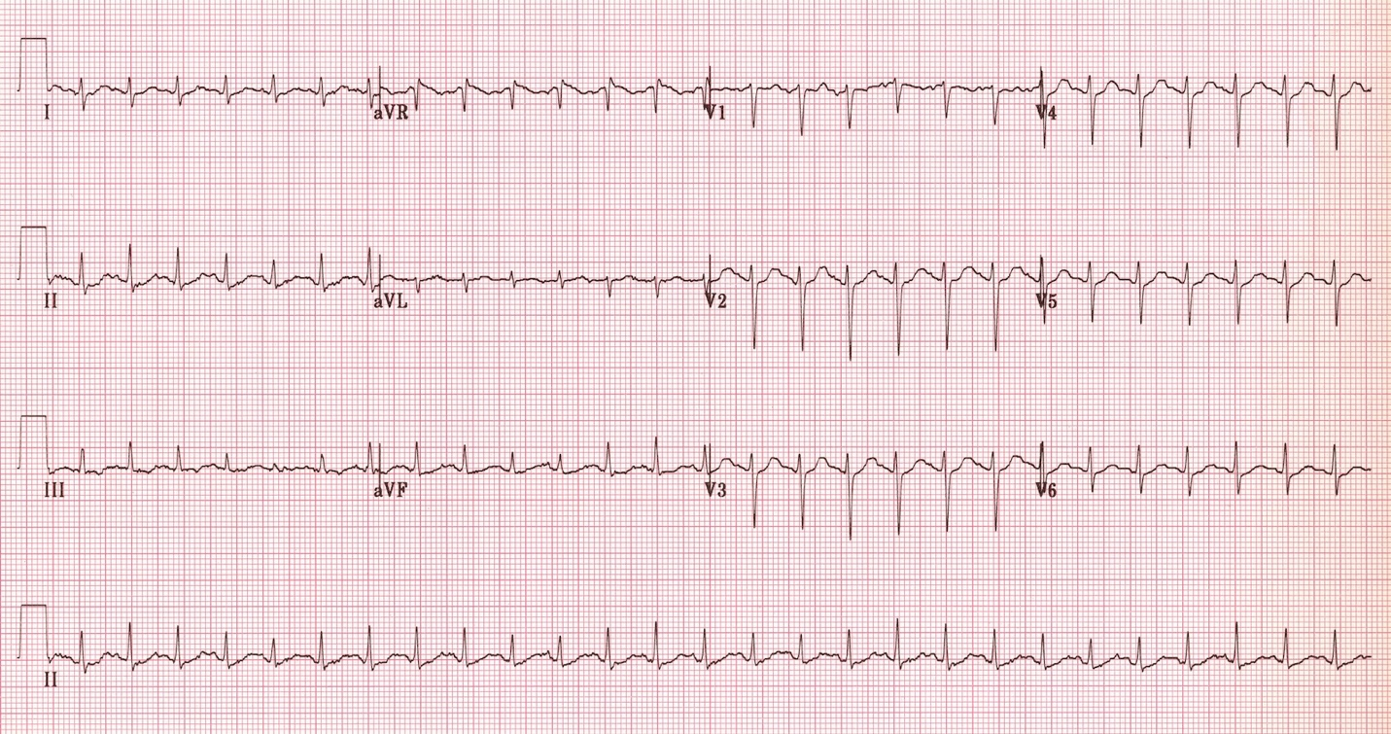
Source: https://lifeinthefastlane.com/ecg-library/myocarditis/

Appendix C: CXR (no change part 1 and 2)

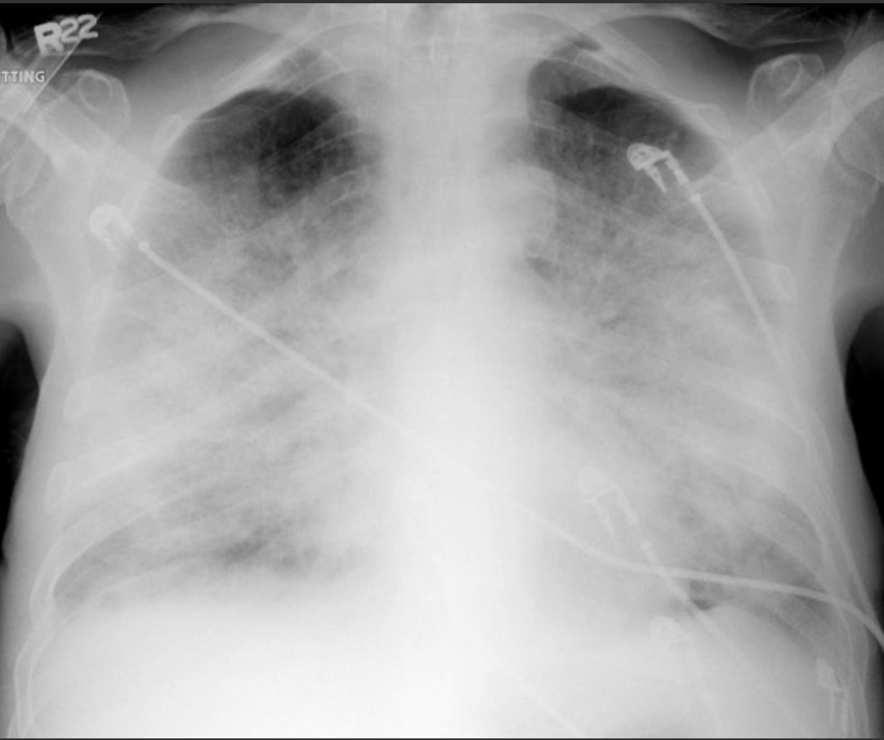
Source: https://www.med-ed.virginia.edu/courses/rad/cxr/pathology2chest.html

Appendix D: Bedside echo (no change part 1 and 2)

“1. Slightly dilated LV. Severe global LV dysfunction with LVEF estimated 10%. Estimated CO of 3.0L/min or C.I of 1.6L/min/m2

2. RV of normal size and function. No signs of PHTN.

3. Mild MR with no other significant valvulopathies

4. Mild pericardial effusion, with no tamponade physiology.

5. Plethoric IVC; CVP estimated 15mmHg.”

Appendix E:

Action | Consequence
Antiarrhythmics | Amiodarone  - Code dose: as per ACLS. 300mg + 150mg  - Non-code dose: 150mg IV over 10 minutes then 1mg/hr  Lidocaine  - 1-1.5mg/kg (70-100mg over 25-50mg/minute rate) – push over 1 minute  - Repeat 0.5-0.75mg/kg bolus (35-50mg bolus) q5-10 minutes.  - Infusion 1-4mg/min  Procainamide  - #1 IV Load: 15-18mg/kg slow infusion over 25-30 minutes  - #2 IV Load (alternative) 100mg IV over 2 minutes (50mg/min) q5 minutes for total of 1g  - Continuous infusion 1-4mg/min until arrhythmia controlled  - (max dose 17mg/kg = 1200mg/day)  Metoprolol  - 2.5-5mg IV over 5 minutes, q5 minutes. Max 15mg
Sedation | Propofol  - 10-50 mcg/kg/min  Versed  - 1-15mg/hr  Fentanyl  - 25-100 mcg/hr
Vasopressors | Norepinephrine  -initial drug for cardiogenic shock  -start at 2-10mcg/min  Vasopressin  - IV infusion: 0.01- 0.04 IV units/min  - Do not exceed 2.4units/hr (0.04 units/min)  Phenylephrine:  -200mcg IV, repeat q15min as needed  - IV infusion: 40-60mcg/min
Inotropes | Dobutamine  -2-20mcg/kg/min  -be careful of use alone in Hypotension  Milrinone  -0.125-0.75 mcg/kg/min, not studied well in CS  -more potent inodilator then dobutamine  Epinephrine (1:1000):  -0.05-0.2 mcg/kg/min  Dobutamine and milrinone aren’t advised in severe hypotension, but mostly in low output states with preserved BP

Debriefing Guide – Cardiogenic Shock
(Adapted from a debriefing guide used at the Massachusetts General Hospital, Boston, MA)

Approach to Hypotension: MAP = CO x SVR (systemic vascular resistance)

↓ MAP = ↓ CO and / or ↓ SVR

First feel the extremities: Normal response to ↓ MAP should be vasoconstriction and cool / cold skin

Warm = ↓ SVR = presumed cause of ↓ MAP
If Cold (SVR seems ok), then it must be ↓ CO (which = HR x SV)

↓ CO = ↓ HR and / or ↓ SV

Address HR first: If acute bradycardia coinciding with acute hypotension, consider as the cause

If HR is ok, it must be the ↓ SV

*Access saves lives: 18 G x 2 or better (smaller G is bigger lumen – colors are green 18, pink 20, blue 22)

*Vital signs are vital: Proportional Pulse Pressure = Pulse pressure / Systolic blood pressure (PPP=SBP-DBP/SBP)
      - If PPP < = 25%, indicates LVF and Cardiac index < = 2.2 L/min/m
      - It is an indicator of LV function

Cardiogenic Shock – characterized by MAP < 60, CI < 2L/min/m2, PCWP > 18 mmHg and evidence of end-organ hypoperfusion (worsening renal function, low UOP, lactate, AMS, etc)

- Severe LV dysfunction (anterior MI)
- Severe extensive ischemia
- Mechanical complication of LVMI (acute MR, IVS rupture, tamponade)

Outcomes: 30d mortality ~ 50%, accounts for 60% of 30d mortality following acute MI (Killip class IV = cardiogenic shock associated with 60-80% mortality)

Treatment Goals: diuresis for goal PCWP < 18mmHg (↓ pulmonary edema, myocardial O2 consumption); afterload reduction to keep SVR < 1200, pressors to keep MAP > 60 mmHg; augment LV function (with inotropes, IABP, mechanical support) to keep CI > 2 L/min/m2
**Overarching goal is to improve perfusion!**

Tailored Therapy Strategy: Optimize CO by optimizing SV and/or HR (Recall: CO = SV x HR)

If bradycardia manage with chronotropic agents / pacing

If tachycardia consider slowing to improve filling of ventricles during diastole (unless sinus tach)

If HR is ok, manage the ↓ SV

- Preload: Stretch of cardiac myocytes, or LVEDV
- LVEDV estimated by LVEDP ~ PCW ~ PA diastolic (assumptions)
- Goal in Cardiogenic Shock – goal PCWP < 18mmHg (↓ pulmonary edema, myocardial O2 consumption)
- Treatment Modalities – diuresis, UF, HD; vasodilators

- Afterload: Load ventricle contracts against (pressure required to open AoV)
- Estimated by SVR and diastolic BP
- Goal in Cardiogenic Shock – vasodilators for SVR < 1200
- Treatment Modalities – nitrates, inodilators (milrinone, dobutamine)

- Contractility: Shortening of myocytes with each cardiac cycle
- Using Fick principle or thermodilution method to estimate CO (L blood / min)
  - Ficks principle -> oxygen extraction (VO2) = (CO x arterial O2 conc) – (CO x venous O2 conc)
  - Rearranged... VO2 = CO (arterial O2 conc – venous O2 conc)
  - Further rearranged... CO = VO2 / (arterial O2 conc – venous O2 conc)
  - Fick CO = O2 consumption (VO 2 in mL O2/min) / [13.4 (Hgb) (SaO2 – MvO2) in mL O2/L blood]
- If all constant (VO2 measured in cath lab), can use MVO2 as a surrogate for CO
- Goal in Cardiogenic Shock – augment CI>2 by optimizing preload, afterload; inotropic agents
- Treatment Modalities – inotropes (dobutamine, milrinone)

PA Catheter Basics
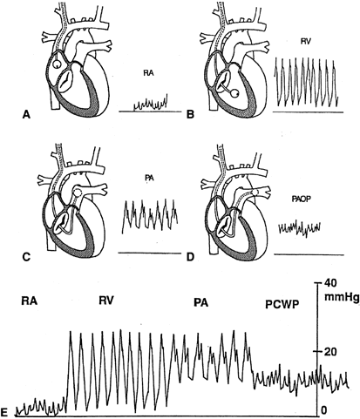
Indications:
(1) Undifferentiated shock state
(2) Congestive heart failure
(3) Pulmonary hypertension
(4) Myocardial infarction complicated by heart failure

Normal Values
- CO ~ 5 - 7 L / min
- CI ~ 2.8 - 4.2 L / min / m2
- SVR ~ 1200 ± 270 dyne-sec-cm⁻⁵
- PVR ~ 70 ± 30 dyne-sec-cm⁻⁵

- NOTE: SVR = ((MAP-RA)/CO) x 80
- NOTE: PVR = ((PA-PCWP)/CO) x 80

Rule of 5s (Normal values)
- RA 5
- RV 25 / 5
- PA 25 / 10
- PCWP 10

Class | Drug | Dose | Mechanism | Side effects
Vasopressor | Phenylephrine  (Neosynephrine) | 10-1000 mcg/min | α1 agonist | Reflex brady
 | Vasopressin | 0.01-0.04 U/min | V-receptor agonist
Mixed: Vasopressor +  Inotrope | Norepinephrine  (Levophed) | 2-100 mcg/min | α1β1 agonist | Arrhythmias  Digital ischemia
 | Dopamine | 10-1000 mcg/min | D>β1/2>α1 agonist (with higher doses) | Arrhythmias
 | Epinephrine | 0.05-10 mcg/min | α1β1β2 agonist | Tachycardia, arrythmias, angina
Inodilator | Dobutamine | 10-1000 mcg/min | β1 agonist | Arrhythmias, hypotension
 | Milrinone | 0.375-0.75 mcg/kg/min | PDE III inhibitor | Arrhythmias, hypotension  *Renally cleared  *Longer T_{1/2} than dobutamine
Chronotrope | Isoproterenol | 0.1-20 mcg/min | β1 agonist | Arrhythmias
Vasodilator | Nitroprusside | 5-800 mcg/min | NO donor | Cyanide toxicity
 | Nitroglycerin | 10-500 mcg/min | NO donor | Reflex tachycardia, hypotension, headache, tachyphylaxis
