- Title: Post procedural bleed

Authors and their affiliations

Author 1 | Tara D’Ignazio, PGY-3 Internal Medicine, Université de Montréal
Senior Author | Nicolas Thibodeau-Jarry, MD, MMSC, Department of Medicine, Institut de cardiologie de Montréal
Institution | Institut de Cardiologie de Montréal/Montreal Heart Institute

- Target Audience: Internal Medicine Junior Residents, Cardiology Fellows

- Learning and Assessment Objectives

Participants are expected to execute the optimal management path as defined below and through the critical actions checklist as well as discuss the pathophysiologic reasoning behind a certain course of treatment. Debriefing sessions should be used to allow each participant to reflect upon the team dynamics and to identify future technical and behavioral goals.

Critical Actions Checklist:

DONE CRITICAL ACTION
□ CAB (circulation, airway, breathing)
􀂆 Telemetry monitoring
􀂆 Rapid patient history
􀂆 Rapid physical examination
□ Identification of key exam findings
􀂆 IV Access
􀂆 Recognize and appropriately treat hemorrhagic shock
􀂆 Obtain labs, imaging (CXR), ECG

- Environment
- Simulation room set up: ER “crash room”
- Mannequin set up:
- High fidelity patient simulator
- Lines needed
- Props:
- Code blue cart
- Lab values
- Images (CXR)
- EKGs
- Echo report

- Distracters: none

- Actors
- Nurse: facilitate scenario
- Consultants: Supervising Resident; Cardiology; Critical Care Attending
- Case Narrative: Part I

SCENARIO

You are the in-house cardiology resident on call overnight and are paged by a nurse for hypotension in a 75-year-old patient who had a coronary angiogram today.

When asked for more details, the nurse tells you the patient was sent from a regional center for an elective angiogram. His procedure occurred around midday and went well. A drug-eluding stent was placed in the LAD, and the patient is thus on clopidogrel and aspirin. The procedure was done via right femoral access.

Current vital signs:
BP 90/60 HR 130 bpm, sinus tachycardia RR 25/min Sat 98% on ambient air

Upon revision of the chart:

75-year-old man
Known for chronic stable angina but recent increase in symptom frequency, no prior revascularization, and referred for angiogram
No history of STEMI
TTE: EF 60%, no wall motion abnormalities, no valvular problem, no pulmonary hypertension
HOME MEDICATIONS | INPATIENT MEDICATIONS | ALLERGIES
Atorvastatin 40mg PO HS | Clopidogrel 75mg PO DIE | Nil
Bisoprolol 10mg PO DIE | ASA 81mg PO DIE
Perindopril 4mg PO DIE (discontinued for angiogram) | Dilaudid 0.5mg S/C q3h PRN, received 30 min ago x 1

Habits: 45 pack year smoker, social drinker, no drugs.

CURRENT STATE
“I feel dizzy”

REVIEW OF SYSTEMS/HPI:
Neuro: No headache or other neurological complaints. No focal symptoms.
Resp: tachypneic, no cough, no pleuritic pain. Slight difficulty breathing since 1 hour ago.
Cardio: No retrosternal pain. No orthopnea in the days prior or presently. No bilateral lower leg edema. No palpitations.
GI: Nauseous. Pain in low abdomen since 2 hours ago
GU: nil, no changes in urinary output. No UTI symptoms.
ID: no fever, no URTI symptoms. No diarrhea.
BMI: 34

All other questions on HPI are negative.

Temperature (ºC) | HR (bpm) | BP (mmHg) | RR (per min) | O₂ Sat
36.7 | 120 | 90/60 | 30 | 98% AA
Cardiac telemetry: sinus tachycardia, p waves visible

PHYSICAL EXAM
Patient able to respond to questions, but diaphoretic and pale
Circulation: peripheral pulses reduced, evidence of peripheral clamping with cold extremities. Capillary refill > 6 seconds in feet
A: protecting airway
B: slight tachypnea but no signs of respiratory distress

Neuro: Alert, nauseous. GCS 15. No focal neuro deficits.
CVS: Normal S1 and S2. No S3 or S4. CVP is difficult to evaluate.
GI: Pain upon palpation of lower right quadrant with guarding. No bruises on the abdomen. No palpable mass.
LE: calves and thighs normal, supple. Site of arterial puncture on right side still covered by compressive bandage. No hematoma at the entry site. No murmur upon auscultation. Presence of pedal and tibial pulses in both feet, equally diminished.
Pain is made worse when the right leg is lifted.

EKG: Sinus tachycardia at 110bpm, no ST/T changes, no q waves

Angiogram from the same day:
LAD occluded 99% → DES x 1 → 0%
D1 30% proximal lesion
RCA NS lesion
Circumflex NS lesion, M1 NS lesion

ASSESSMENT AND MANAGEMENT (2 parts)

Part 1
- The learner will need to recognize an acutely ill patient, with evidence of a beginning hemorrhagic shock state at risk of deteriorating.
- The learner must undertake steps to stabilize the patient’s hemodynamic status.
- The learner must evoke the diagnosis of post-procedural bleed, while excluding other dangerous diagnoses such as post-procedural tamponade.
- The learner must be able to initiate the steps leading to the confirmation of the diagnosis of a post-procedural bleed and initiate steps towards appropriate intervention.

Time-out 1: what is your primary diagnosis at this point? Which steps would you undertake immediately?

Are there any other diagnoses you would want to eliminate in a patient who just had an angiogram?

Vascular complications:
- Femoral pseudoaneurysm
- AV fistula
- Femoral dissection
- Access site hematoma
- Retroperitoneal bleed
Cardiac causes:
- Cardiac tamponade
- Stent thrombosis

At this point, the learner should :
- Establish minimum 2 IV access and establish appropriate monitoring
- Ask for supplemental information: labs, cardiac Quick Look to rule out tamponade
- Plan an abdominal CT with contrast to rule out retroperitoneal hemorrhage
- Begin interventions to improve hemodynamics

Flow according to interventions:

Hemodynamics

*** If fluids (minimum 500cc) are given, vitals will change to:
Temperature (ºC) | HR (bpm) | BP (mmHg) | RR (per min) | O₂ Sat
37.6 | 110 | 100/80 | 25 | 95% via AA

**If 1L given

Temperature (ºC) | HR (bpm) | BP (mmHg) | RR (per min) | O₂ Sat
37.6 | 100 | 110/85 | 25 | 95% via AA

** If 2L given

Temperature (ºC) | HR (bpm) | BP (mmHg) | RR (per min) | O₂ Sat
37.6 | 90 | 120/80 | 20 | 95% via AA

*** If beta-blockade, calcium channel blockers, or amiodarone are given, nurse will prompt: “Doc, the patient’s BP is x/x (low).”
If insists, 2nd prompt: “Doc I don’t think that’s a good idea”
If administered, patient will become semi-responsive with VS below
Temperature (ºC) | HR (bpm) | BP (mmHg) | RR (per min) | O₂ Sat
37 | 60 | 70/40 | 27 | 98% AA

** If norepinephrine or phenylephrine are given

Temperature (ºC) | HR (bpm) | BP (mmHg) | RR (per min) | O₂ Sat
37 | 125 | 100/80 | 27 | 98% AA

** vital sign changes are ballpark, and can obviously be modified, especially in context of multiple simultaneous interventions**

CONSULTANTS

ICU: The CCU resident tells you there is no bed at the moment. The patient is normotensive after your interventions, and she just received two Kilip 4 STEMIs.

Radiology: the resident tells you the patient can have their scan and will call back with results. The resident suggests using contrast for the scan, provided the patient is not allergic.

Interventional fellow: confirms that the patient does not have a stent thrombosis or tamponade. No other interventions for the time being.

Paraclinical exams:

Labs:
CBC: WBC 8, Hb 90 (earlier that day 120), Platelets 120
Creatinine 62, K+ 4.2
ABG: 7.35/35/24
Troponins HS 0.1

INR: 1.2
PTT: 26
Fibrinogen: 3.2

CXR: Normal
Quick Look ultrasound subxiphoid view: no pericardial effusion, no interventricular dependence

Time-out 2: what would you order given the results?

Appropriate interventions:
- Cross match of packed red blood cell units
- Order 2 units of packed red blood cells
- No indication for fresh frozen plasma or prothrombin complex (INR 1.2)
- No indication for platelet transfusion (platelets > 50)
- No indication for cryoprecipitate (fibrinogen > 2)
- No role for protamine since PTT is now normalized (>4h since IV heparin dose)
- Bolus LR or NS, start maintenance fluid >100cc/h
- Transfusion of red blood cells could be appropriate in this case, because the patient probably has a lower hemoglobin than what has been found. Of note, the patient has undergone a complete revascularization and so a threshold of >70 would be appropriate. Too many transfusions could be pro-thrombotic at this point as well.

Part 1 ends when the patient is volume repleted, sent to angioscan in the company of the resident.
Appropriate volume repletion = around 2L in this scenario

Part 2

The patient returns from his angioscan. The resident in radiology calls you immediately and informs you that he detects an active right retroperitoneal bleed.

The patient’s vital signs are as follows:

Temperature (ºC) | HR (bpm) | BP (mmHg) | RR (per min) | O₂ Sat
38 | 100 | 100/80 | 25 | 98% AA

Time-out 3: Which intervention do you propose at this time?

The learner should propose angio-embolization for an active bleed, and contact interventional radiology for the next steps.

End of scenario.

***Any further dose increase or non-interventional management will have no effect on vital signs.

**SCENARIO ENDS ONCE PARTICIPANT CALLS ICU ATTENDING REGARDING POSSIBILITY OF TRANSFER TO IR-CAPABLE CENTRE**

- Instructor Notes Medical Management of Post Procedural Bleed
- Tips to keep scenario flowing
- If need for further evaluation not recognized, nurse will make a suggestion for further evaluation.
- Nurse will prompt students to obtain baseline TESTS if not requested.
- Nurse will prompt contacting consultants/RICU if not requested.

- Scenario programming
- Optimal management path
      - O₂/IV/monitor
      - History and physical examination
      - Requisite studies
        - Labs: CBC, creatinine
        - Images: ECG, abdominal scan, TTE

      - Consulting IR

- Potential complications/errors path(s):
      - Failure to recognize hemorrhagic shock
      - Failure to ask for scan
      - Failure to volume repleat the patient

- Debriefing
- Method of debriefing: Group with teaching materials
- Didactic Material

Appendix A: Labs

Part 1

Na⁺ |  | 139 |  | 135-147 mMol/L
K⁺ |  | 4.2 |  | 3.5-5.2 mMol/L
Cl⁻ |  | 97 |  | 95-107 mMol/L
HCO₃⁻ |  | 22 |  | 22-30 mMol/L
BUN |  | 6 |  | 7-20 mMol/L
Cr |  | 62 |  | 53-120 μMol/L
Glucose |  | 6 |  | 3.9-6.1 mMol/L
Mg ++ |  | 1.0 |  | 1.4-2.0 mEq/L
Ca ++ |  | 8.6 |  | 8.5-10.5 mg/dL
CBC w Differential |  |  |  | Reference Range
WBC |  | 8 |  | 4.5-11 th/cmm
Hgb |  | 90 |  | 12-16 gm/dl
Hct |  | 38.2 |  | 36-46%
MCV |  | 101 |  | 8—100 fl
PLT |  | 120 |  | 150-400 th/cmm
PMNs |  | 58 |  | 40-70%
Lymph |  | 30 |  | 22-44%
Eos |  | 3 |  | 0-8%
Cardiac Biomarkers |  |  |  | Reference Range
NT-BNP |  | 230 |  | < 190
cTnT  D Dimer |  | 0.01  120 |  | <0.03 ng/mL
Coagulation Profile |  |  |  | Reference Range
PTT |  | 26 |  | 25-34 sec
INR |  | 1.2 |  | 0.8-1.2
Fibrinogen |  | 300 |  | 170 – 420 mg/dL
Liver Function Tests |  |  |  | Reference Range
Albumin | 4.1 |  | 3.3-5.0 gm/dl
ALT | 16 |  | 7-30 U/L
AST | 17 |  | 9-32 U/L
DBili | 3 |  | 2-7 μMol/L
TBili | 11 |  | 0-17 μMol/L
Alk Phos | 86 |  | 30-100 U/L

Blood gas analysis |  |  | Reference Range
pH | 7.35 | 7.35-7.45
PCO2 | 35 | 35-45 mmHg
PO2 | 89 | 75-100mmHg
HCO3- | 24 | 22-26 meq/L
Lactate | 2.4 | 0-2 mmol/L

Appendix B: EKG (no change part 1 and 2)
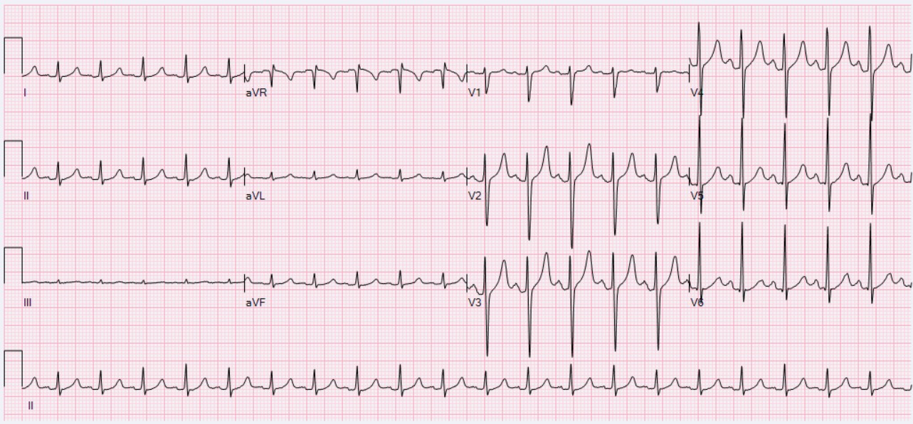
https://en.wikipedia.org/wiki/Sinus_tachycardia#/media/File:ECG_Sinus_Tachycardia_125_bpm.jpg

Appendix C: Bedside echo (no change part 1 and 2)

“1. LV normal, FEVG 60%, no regional abnormalities of contractility

2. RV normal

3. No significant valvulopathies

4. No pericardial effusion, with no tamponade physiology, no ventricular interdependence

5. CVP estimated at 8 cmH2O

