Submassive Pulmonary Embolism Simulation
Scenario:
- Title: Submassive Pulmonary Embolism

Authors and their affiliations

Author 1 | Tara D’Ignazio, PGY-3 Internal Medicine, Université de Montréal
Senior Author | Nicolas Thibodeau-Jarry, MD, MMSC, Department of Medicine, Institut de cardiologie de Montréal
Institution | Institut de Cardiologie de Montréal/Montreal Heart Institute

Target Audience: Internal Medicine Junior Residents, Cardiology Fellows

Learning and Assessment Objectives

Participants are expected to execute the optimal management path as defined below and through the critical actions checklist as well as discuss the pathophysiologic reasoning behind a certain course of treatment. Debriefing sessions should be used to allow each participant to reflect upon the team dynamics and to identify future technical and behavioral goals.

Critical Actions Checklist:

DONE CRITICAL ACTION
□ CAB (circulation, airway, breathing)
􀂆 Telemetry monitoring
􀂆 Rapid patient history
􀂆 Rapid physical examination
□ Identification of key exam findings
􀂆 IV Access + invasive hemodynamic monitoring
􀂆 Recognize and appropriately treat cardiogenic shock, including eventual need for mechanical support
􀂆 Obtain labs, imaging (CXR), ECG
□ Recognize progressive respiratory failure requiring intubation

Environment
- Simulation room set up: ER “crash room”
- Mannequin set up:
- High fidelity patient simulator
- Lines needed
- Props:
- Code blue cart
- Lab values
- Images (CXR)
- EKGs
- Echo report
- Distracters: none

Actors
- Nurse: facilitate scenario
- Consultants: Supervising Resident; Cardiology; Critical Care Attending
- Case Narrative: Part I

SCENARIO

You are the in-house resident on call overnight and are called for a cardiology consultation for “tachycardia”.

You read through the chart. The consult has been asked for a 24-year-old woman, who is followed by psychiatry at the hospital at which you work. She has been in the emergency room multiple times for panic attacks due to a generalized anxiety disorder, which is treated with SSRIs. Today, in triage, the patient reports feeling a sudden onset of palpitations and lightheadedness, which prompted her to call 911.

On arrival, the patient’s vital signs were:
HR: 135bpm
BP: 100/60
Sat: 90% on room air, RR 35
T 38 C

The patient was evaluated by your colleague in the emergency room and administered inhaled salbutamol for her respiratory distress and a bolus of 500cc of normal saline. She has been put on telemetry due to her high heart rate.

HOME MEDICATIONS  (not currently taking) | INPATIENT MEDICATIONS | ALLERGIES
Sertraline 50mg PO DIE | Ventolin 4 inh q30 min x 3 | Nil
Lorazepam 0.5 mg PO PRN (max BID) | NS 500 cc x 1
Evra transdermal patch q 1 week

Past medical hx:
Followed by psychiatry for a Generalized Anxiety Disorder, well controlled with SSRI and occasional Lorazepam (1x month, no recent change in frequency)

Habits: Non-tobacco smoker, social drinker, occasional marijuana. No amphetamines. No IV drugs.

CURRENT STATE
“I can’t breathe, I’m having difficulty getting air in”

REVIEW OF SYSTEMS/HPI:
Neuro: No headache or other neurological complaints. Anxious.
Resp: tachypneic, no increase in expiratory time. No hemoptysis. No cough or increase in sputum. If asked: the patient will respond she has pain when she inhales (pleuritic pain).
Cardio: No retrosternal pain. No orthopnea in the days prior. No bilateral lower leg edema, but one leg larger than the other. Feels palpitations since two hours ago, with abrupt onset.
GI/GU: nil, no changes in urinary output. No UTI symptoms.
ID: no fever, no URTI symptoms. No diarrhea.
BMI: 35

All other questions on HPI (travel, infectious hx, B-symptoms, etc) are negative.

If specifically asked:
Patient recently came back from a road trip from 6 hours away. She did not take breaks on her way back other than for gas. Since this time, her left thigh has been hurting. Pain is described as “crampiform”.
No recent surgery.
No recent trauma.
No prior thrombotic events.
No active cancer.
No family history of recurrent thrombosis.

Temperature (ºC) | HR (bpm) | BP (mmHg) | RR (per min) | O₂ Sat
38.0 | 140 | 100/60 | 35 | 88% AA
Cardiac telemetry: tachycardia, p waves difficult to identify given tachycardia

PHYSICAL EXAM
Looks in visible distress, dyspneic, has difficulty completing sentences
Circulation: 1+ tibial pulses
A: protecting airway
B: dyspneic and tachypneic, struggling to complete sentences
Glucose (if asked) normal 6.4

Neuro: Alert, anxious. GCS 15. No focal neuro deficits.

CVS: Normal S1, loud S2. S3 +. Holosytolic murmur which increases with inspiration.
Resp: no wheezing, no stridor, no crackles. JVP +4
GI: soft abdomen, nil acute
LE: calves normal, supple. Pain in left thigh, worsened upon palpation

ASSESSMENT AND MANAGEMENT (2 parts)

Part 1

- The learner will have need to recognize an acutely ill patient, with evidence of a pre-shock state at risk of deteriorating.
- The learner must undertake steps to stabilize the patient’s hemodynamic status.
- The learner will have to evoke and then conform the diagnosis of a submassive pulmonary embolism.
- The learner must be able to initiate the steps leading to the confirmation of diagnosis of pulmonary embolism, while not delaying the initiation of appropriate treatment (in this case, anticoagulation)

- Case will evolve towards progressive respiratory distress requiring intubation regardless of prior interventions.

Time-out 1: what is your primary diagnosis at this point? Which steps would you undertake immediately?

At this point, the learner should :
- Establish minimum 2 IV access, supplemental O₂, monitor, place patient in reanimation bay if this is not already the case
- Ask for supplemental information: labs, EKG, CXR, cardiac Quick Look
- Plan a CT angiogram, direct discussion with radiologist
- Initiate anticoagulation before receiving results of angioscan
- Begin interventions to improve hemodynamics

Flow according to interventions:

Hemodynamics

*** If fluids are given, vitals will change to:
Temperature (ºC) | HR (bpm) | BP (mmHg) | RR (per min) | O₂ Sat
37 | 120 | 100/80 | 37 | 88% via AA

*** If beta-blockade, calcium channel blockers, or amiodarone are given, nurse will prompt: “Doc, the patient’s BP is x/x (low).”
If insists, 2nd prompt: “Doc I don’t think that’s a good idea”
If administered, patient will become semi-responsive with VS below
Temperature (ºC) | HR (bpm) | BP (mmHg) | RR (per min) | O₂ Sat
37 | 80 | 80/50 | 26 | 80% AA

** vital sign changes are ballpark, and can obviously be modified, especially in context of multiple simultaneous interventions**

If the learner wishes to thrombolyse the patient, the nurse can refuse on the basis of having never done it and insist that the attending be present. If the learner insists, they must call the pharmacy to prepare the dose of tPA based on the patient’s weight and respond to the pharmacist’s questions regarding possible contraindications to thrombolysis.

Oxygenation

*** If increased fiO2 is used, vital signs will change to:
Temperature (ºC) | HR (bpm) | BP (mmHg) | RR (per min) | O₂ Sat
37 | 140 | unchanged | 30 | 92% via 100%

*** If NiV is used, vital signs will change to:
Temperature (ºC) | HR (bpm) | BP (mmHg) | RR (per min) | O₂ Sat
37 | 145 | 80/50 (due to positive pressure) | 24 | 95% via 100%

Nurse prompt: “Doc, the patient is not tolerating BiPaP very well, and her sat keeps on dropping. She’s less responsive too. Is there anything else we could do?”

CONSULTANTS

ICU:
The ICU resident tells you there is no bed at the moment. The patient is still technically normotensive, and she just received two polytraumas.

Paraclinical exams:

Labs:
CBC: WBC 11, Hb 134, Platelets 180
Creatinine 62, K+ 4.2
ABG: 7.50/28/22 PaO2 70mmHg
D-Dimer 4000
BNP 1000
Troponins HS 5

EKG: Sinus tachycardia at 140bpm
CXR: Normal
Quick Look ultrasound short axis view:
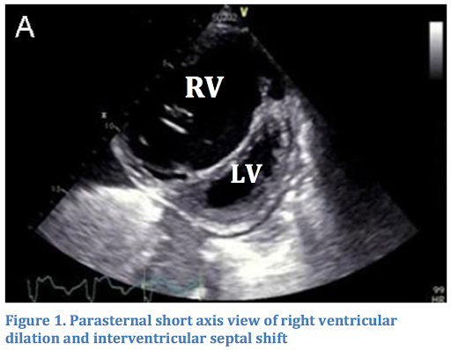

Part 1 ends when the patient is volume repleted, sent to angioscan in the company of the resident, and appropriate anticoagulation has been initiated.

Part 2

The patient returns to the reanimation bay after her angioscan. The resident in radiology calls you immediately and informs you that she detects a pulmonary embolism saddling the left and right main pulmonary arteries with signs of right ventricular strain.

Meanwhile, the patient begins to show signs of respiratory fatigue. Her respiratory rate is steadily decreasing, and she is becoming increasingly somnolent.

The patient’s vital signs are as follows

Temperature (ºC) | HR (bpm) | BP (mmHg) | RR (per min) | O₂ Sat
38 | 155 | 90/60 | 16 | 80% with FiO2 100%

Minimal urine output
Lactate: 4 mmol/L
Repeat ABG: 7.35/38/22 PaO2 65mmHg

Time Out 2
At this point, the nurse asks you what you would like to do with the patient.

Recap:
Airway: still protected, but patient becoming less responsive
Breating: Sat O2 80% at FiO2 100%
Circulation: BP 90/60 with HR 155

Step 1) Management of Airway
Ideally the learner should recognize the precarity of the situation and call for backup at this point. Either the ICU fellow or anesthesiology fellow can be called at this point. Both will reply that they are on their way, but to manage the patient in the meanwhile.

**Intubation before hemodynamic stabilization
If the learner attempts to intubate the patient without achieving hemodynamic stability prior, the patient will code upon intubation (bradycardia and then electrical activity without a pulse)
If the learner attempts to intubate using cardiodepressive agents such as propofol, the patient will code upon intubation

Temperature (ºC) | HR (bpm) | BP (mmHg) | RR (per min) | O₂ Sat
37 | 140 | 70/40 | 16 | 100% with FiO2 100% once intubated

**Vasopressors prior to intubation

Temperature (ºC) | HR (bpm) | BP (mmHg) | RR (per min) | O₂ Sat
37 | 130 | 120/80 | 16 | 100% with FiO2 50% once intubated

The patient has been successfully intubated by the learner.

Step 2) Management of hemodynamics

The ET tube is confirmed to be in the correct position with confirmed expiratory CO2 curve.
The patient’s vital signs are as follows post intubation and on levophed 30mcg/min:

Temperature (ºC) | HR (bpm) | BP (mmHg) | RR (per min) | O₂ Sat
37 | 130 | 80/55 | 16 | 100% with FiO2 50% once intubated

DISCUSSION POINTS: what should be done next?
- If the learner mentions thrombolysis, ask if the patient has any contraindications to the procedure.

Rapid review of thrombolysis contraindications should be asked prior to administration of tPA
Learner can call pharmacy for dose calculation and administration of tPA in this hemodynamically unstable patient.

Vital signs post thrombolysis:

Temperature (ºC) | HR (bpm) | BP (mmHg) | RR (per min) | O₂ Sat
37 | 140 | 90/60 | 16 | 100% with FiO2 50% once intubated

Given the poor response to thrombolysis, what is the next step?

- Dobutamine and levophed should be started as per the dosage in Appendix E.

Despite the initiation of dobutamine at 15mcg/kg/min and levo at 40 mcg/min, the patient’s MAP is consistently < 65mmHg

- Learner must recognize persistent/refractory RV shock despite intensive medical management and should think about alternative support methods such as mechanical devices.
- In the case of RV shock, the most widely available choice at this point would be referral to a VA ECMO capable site

***Any further dose increase or non-interventional management will have no effect on vital signs.
***If indecision, nurse will suggest: “Should we start thinking of non-pharmacological interventions?”

**SCENARIO ENDS ONCE PARTICIPANT CALLS ICU ATTENDING REGARDING POSSIBILITY OF TRANSFER TO ECMO-CAPABLE CENTRE**

Instructor Notes Medical Management of Submassive Pulmonary Embolism
- Tips to keep scenario flowing
- If need for further evaluation not recognized, nurse will make a suggestion for further evaluation.
- Nurse will prompt students to obtain baseline TESTS if not requested.
- Nurse will prompt contacting consultants/RICU if not requested.

- Scenario programming
- Optimal management path
      - O₂/IV/monitor
      - History and physical examination
      - Requisite studies
        - Labs: BNP, CBC, cardiac markers, coagulation profile
        - Images: ECG, CXR
      - Consulting for evaluation for mechanical support

- Potential complications/errors path(s):
      - Failure to recognize cardiogenic shock (as opposed to other causes)
      - Failure to recognize worsening hypoxemia despite non-invasive attempts at oxygenation
      - Administration of negative inotropes in the setting of cardiogenic shock
      - Administration of vasopressors without inotropes

Debriefing
- Method of debriefing: Group with teaching materials
- Didactic Material

Appendix A: Labs

Part 1

Na⁺ |  | 139 |  | 135-147 mMol/L
K⁺ |  | 4.2 |  | 3.5-5.2 mMol/L
Cl⁻ |  | 97 |  | 95-107 mMol/L
HCO₃⁻ |  | 22 |  | 22-30 mMol/L
BUN |  | 6 |  | 7-20 mMol/L
Cr |  | 62 |  | 53-120 μMol/L
Glucose |  | 6 |  | 3.9-6.1 mMol/L
Mg ++ |  | 1.0 |  | 1.4-2.0 mEq/L
Ca ++ |  | 8.6 |  | 8.5-10.5 mg/dL
CBC w Differential |  |  |  | Reference Range
WBC |  | 12 |  | 4.5-11 th/cmm
Hgb |  | 134 |  | 12-16 gm/dl
Hct |  | 38.2 |  | 36-46%
MCV |  | 101 |  | 8—100 fl
PLT |  | 180 |  | 150-400 th/cmm
PMNs |  | 58 |  | 40-70%
Lymph |  | 30 |  | 22-44%
Eos |  | 3 |  | 0-8%
Cardiac Biomarkers |  |  |  | Reference Range
NT-BNP |  | 1000 |  | < 190
cTnT  D Dimer |  | 20  4000 |  | <0.03 ng/mL
Coagulation Profile |  |  |  | Reference Range
PTT |  | 28 |  | 25-34 sec
INR |  | 1.8 |  | 0.8-1.2
Fibrinogen |  | 300 |  | 170 – 420 mg/dL
Liver Function Tests |  |  |  | Reference Range
Albumin | 4.1 |  | 3.3-5.0 gm/dl
ALT | 16 |  | 7-30 U/L
AST | 17 |  | 9-32 U/L
DBili | 3 |  | 2-7 μMol/L
TBili | 11 |  | 0-17 μMol/L
Alk Phos | 86 |  | 30-100 U/L

Blood gas analysis |  |  | Reference Range
pH | 7.45 | 7.35-7.45
PCO2 | 27 | 35-45 mmHg
PO2 | 78 | 75-100mmHg
HCO3- | 22 | 22-26 meq/L
Lactate | 1 | 0-2 mmol/L

Part 2

Blood gas analysis |  |  | Reference Range
pH | 7.25 | 7.35-7.45
PCO2 | 38 | 35-45 mmHg
PO2 | 68 | 75-100mmHg
HCO3- | 22 | 22-26 meq/L
Lactate | 4 | 0-2 mmol/L

Appendix B: EKG (no change part 1 and 2)

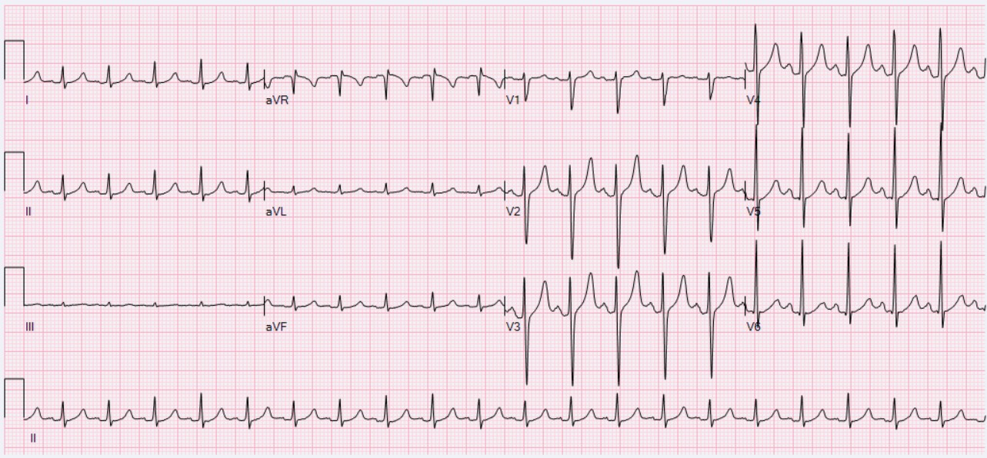
https://en.wikipedia.org/wiki/Sinus_tachycardia#/media/File:ECG_Sinus_Tachycardia_125_bpm.jpg

Appendix C: CXR (no change part 1 and 2)

Appendix D: Bedside echo (no change part 1 and 2)

“1. LV normal, FEVG 60%

2. RV increased in size and severely dilated

3. Severe TR with no other significant valvular problem

4. No pericardial effusion, with no tamponade physiology.

5. Plethoric IVC; CVP estimated 15mmHg.”

Appendix E:

Action | Consequence
Antiarrhythmics | Amiodarone  - Code dose: as per ACLS. 300mg + 150mg  - Non-code dose: 150mg IV over 10 minutes then 1mg/hr  Lidocaine  - 1-1.5mg/kg (70-100mg over 25-50mg/minute rate) – push over 1 minute  - Repeat 0.5-0.75mg/kg bolus (35-50mg bolus) q5-10 minutes.  - Infusion 1-4mg/min  Procainamide  - #1 IV Load: 15-18mg/kg slow infusion over 25-30 minutes  - #2 IV Load (alternative) 100mg IV over 2 minutes (50mg/min) q5 minutes for total of 1g  - Continuous infusion 1-4mg/min until arrhythmia controlled  - (max dose 17mg/kg = 1200mg/day)  Metoprolol  - 2.5-5mg IV over 5 minutes, q5 minutes. Max 15mg
Sedation | Propofol  - 10-50 mcg/kg/min  Versed  - 1-15mg/hr  Fentanyl  - 25-100 mcg/hr
Vasopressors | Norepinephrine  -initial drug for cardiogenic shock  -start at 2-10mcg/min  Vasopressin  - IV infusion: 0.01- 0.04 IV units/min  - Do not exceed 2.4units/hr (0.04 units/min)  Phenylephrine:  -200mcg IV, repeat q15min as needed  - IV infusion: 40-60mcg/min
Inotropes | Dobutamine  -2-20mcg/kg/min  -be careful of use alone in Hypotension  Milrinone  -0.125-0.75 mcg/kg/min, not studied well in CS  -more potent inodilator then dobutamine  Epinephrine (1:1000):  -0.05-0.2 mcg/kg/min  Dobutamine and milrinone aren’t advised in severe hypotension, but mostly in low output states with preserved BP

