Simulation: Cardiac Tamponade

Authors and institution:

Author 1 | Dr Philippe Joly (PGY4 Cardiology)
Senior Author | Nicolas Thibodeau-Jarry, MD, MMSC, Department of Medicine, Institut de cardiologie de Montréal
Institution | Institut de Cardiologie de Montréal/Montreal Heart Institute

Targeted audience:

Cardiology resident | CCU / ICU nurse
Cardiac surgery resident
ICU resident
Emergency medicine resident

Participants: 1 resident (+ 1 nurse, + 1 simulation manager)
Duration: Introduction (10 min), Simulation (30 minutes), Feedback (20 minutes)
Material: patient monitor simulator, ultrasound guided pericardiocentesis simulator
Environment: community-based hospital emergency room
Learning objectives:
- To recognize cardiac tamponade as a potentially life-threatening complication of acute pericarditis.
- To recognize the main clinical features of acute cardiac tamponade.
- To perform:
  - a targeted history and physical examination (including jugular vein examination and pulsus paradoxus measurement technique)
  - a point-of-care focused cardiac ultrasound (2D images: pericardial effusion, cardiac chambers collapse and IVC plethora. PW doppler: respiratory variation in transvalvular velocities)
- To recognize clinical instability, provide immediate hemodynamic support and perform urgent pericardiocentesis.
- To use a closed-loop communication strategy during a medical emergency.
Suggested resources (preparatory readings):
- Chiabrando JG et al. Management of Acute and Recurrent Pericarditis (JACC State-of-the-Art Review) 2020;75(1):76-92.
- Fitch MT, Nicks BA, Pariyadath M, McGinnis HD and Mathey DE. Emergency Pericardiocentesis. N Engl J Med 2012;366;e17.
- Klein AL et al. American Society of Echocardiography Clinical Recommendations for Multimodality Cardiovascular Imaging of Patients with Pericardial Disease. J Am Soc Echocardiogr 2013;26:965-1012.
- Spodick DH. Acute Cardiac Tamponade. N Engl J Med 2003; 349:684-90.
- Roy CL, Minor MA, Brookhart MA and Choudhry NK. Does this Patient with a Pericardial Effusion have Cardiac Tamponade? JAMA 2007;297:1810-1818
Case narrative: Cardiac Tamponade
* Provide the triage note below to the participant before he enters the simulation room:
TRIAGE
60 yo female brought in by EMS after she called 911 for severe shortness of breath and lightheadedness.
Priority 2
BP 95/50 HR 120 (regular) SaO2 88% Glucose 4.2 T° 37.2
The patient just arrived in the resuscitation area of your emergency department. Please evaluate and manage this patient.

60-year-old female patient, retired
Chief complaint: Acute dyspnea
Past medical history
- Acute idiopathic pericarditis (1st episode) diagnosed 2 weeks ago
- High blood pressure. Mild asthma (well controlled). No CAD/CKD/DM.
- No neoplastic, infectious or auto-immune disease
No family history
No allergy
No smoking. Rare alcohol consumption. No IV drug. No recent travel.
Medications

- Perindopril Plus 2/0,625 mg OD
- Colchicine 0,6 mg BID
- Ibuprofen 600 mg TID
- Pantoprazole 40 mg OD
- Ventolin, Symbicort

History of present illness
Clinical deterioration since the ER visit 2 weeks ago for acute pericarditis. Had to stop ibuprofen because of heartburn.
Gradual dyspnea (now at rest) and cough over the last 4 days with dizziness, extreme exhaustion, loss of appetite and chest tightness. No loss of consciousness.
No weight loss. No fever. No sputum nor other infectious symptoms.
Initial physical examination
Patient in mild respiratory distress. Diaphoretic.
Vital signs: HR 120 (sinus tachycardia), BP 95/50, SpO2 88% (on room air), RR 25, Temp 37.2 (R)
Distended neck veins. Blunted y descent (xx’ > y)
Muffled heart sounds. No murmur. No pericardial friction rub.
Soft abdomen
Clear lungs. No peripheral edema. Cool extremities.
(Pulsus paradoxus 13 mmHg)

Diagnostic studies (provided to the participant when asked for)
Laboratory values:
 | Today | 2 weeks ago | Reference
WBC (x 10⁹/L) | 15 (H) | 7 | 3.5-12
Hgb (g/L) | 125 | 140 | 120-180
PLT (x 10⁹/L) | 420 | 350 | 150-400
CREAT (um/L) | 85 | 45 | 50-110
POTASSIUM (mmol/L) | 3.7 | 4.1 | 3.5-5.1
hs-CRP (mg/L) | 8 (H) | 7 | < 3
LACTATE (mmol/L) | 3 (H) |  | 0.5-2.2
hs-cTnT (ng/L) | 8 | 7 | < 14
TSH (mIU/L) |  | 2.5 | 0.7-6.4

EKG: sinus tachycardia with electrical alternans (prior EKG from 2 weeks ago could also be provided with typical findings of acute pericarditis).
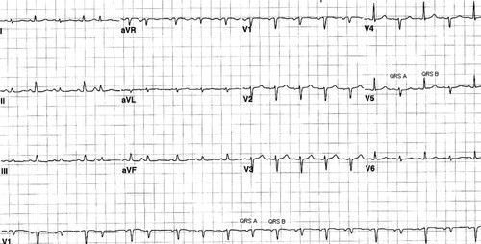
Source: Sreedhar Billakanty. Circulation. Echocardiographic Demonstration of Electrical Alternans, Volume: 113, Issue: 24, Pages: e866-e868, DOI: (10.1161/CIRCULATIONAHA.105.590430)

CXR: enlarged cardiac silhouette, clear lung fields Source: case courtesy of Assoc Prof Frank Gaillard, Radiopaedia.org, rID: 7142

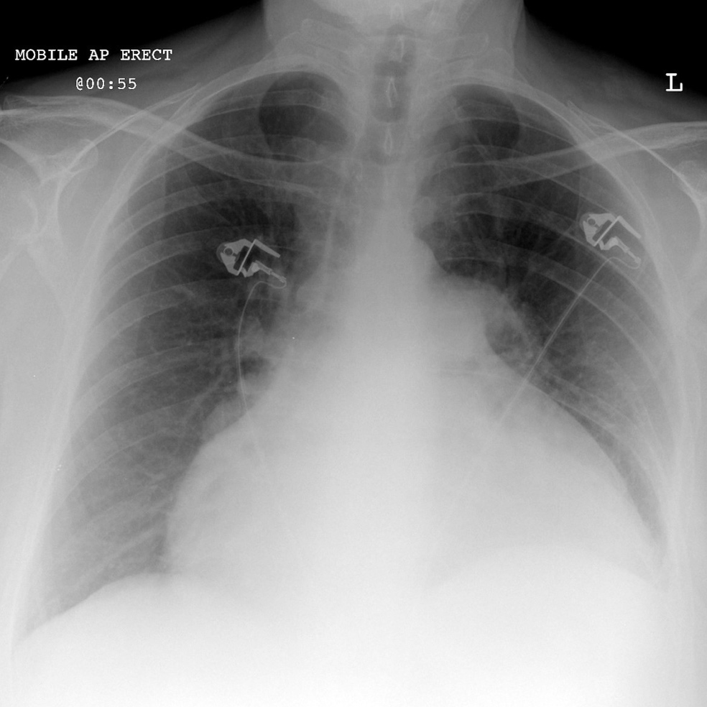

Echocardiography: (ideally on an ultrasound simulator)
- moderate to severe circumferential pericardial effusion
- dilated IVC
- collapse of the right atrium
- increased mitral flow variation (> 30%)

Instructor’s note

 | Simulation progression | Clinical evolution
0-5 minutes | The participant should perform a targeted history and physical examination (using a C-A-B approach).  Appropriate monitoring (cardiac monitor / serial noninvasive blood pressure) should be initiated + IV access. | see Clinical scenario above for details (vital signs, etc.)
5-10 minutes | The participant should be given the following investigations when he/she asks for them:  - Blood test results  - EKG  - CXR  The participant should perform a targeted cardiac ultrasound. | If oxygen initiated SpO2 95%  Otherwise clinically stable  A diagnosis of cardiac tamponade should be made.
10-15 minutes | The participant should monitor the clinical status and appropriately manage the patient.  The participant should get prepared for an emergency pericardiocentesis. | Blood pressure drops to 75/40, sinus tachycardia 135, altered mental status  If IV fluids are administered BP goes back to 95/55  If no recognition of BP drop gradual clinical deterioration PEA  see Emergency Pericardiocentesis: Checklist below  If no explanation about the upcoming procedure is given to the patient patient should manifest anxiety
15-30 minutes | The participant performs pericardiocentesis on the simulator.  The participant ensures appropriate disposal of the patient (CCU/ICU). | see Emergency Pericardiocentesis: Checklist below

Emergency pericardiocentesis: checklist

The participant:
- briefly explains the procedure to the patient.
- gathers the required equipment:
  - sterile gown/gloves/drapes
  - an ultrasound machine with sterile probe cover and ultrasound gel
  - a pericardiocentesis kit including a 20cc syringe with an appropriate needle (16-18 gauge) and a 3-way stopcock (could also include a 6-8 Fr pigtail drainage catheter with a J-tipped guidewire)
  - resuscitation material including a crash cart
- establishes two IV access and asks for continuous hemodynamic monitoring.
- ensures adequate positioning of the patient (head of the bed raised to a 30-45° angle).
- ensures a sterile non-painful technique including skin preparation with an antibacterial cleanser, sterile drapings and local anesthesia.
- performs pericardiocentesis using a subxiphoid approach with real-time ultrasound imaging (the needle should be inserted between the xiphoid process and left costal margin at a 15-30° angle).
- if needed, performs resuscitation maneuver in the event of PEA.
- admits the patient to the CCU/ICU for postprocedural surveillance.

Debriefing plan (based on the CanMEDS framework)

Role: Scholar
- Review the clinical presentation of cardiac tamponade including Beck’s triad and pulsus paradoxus.
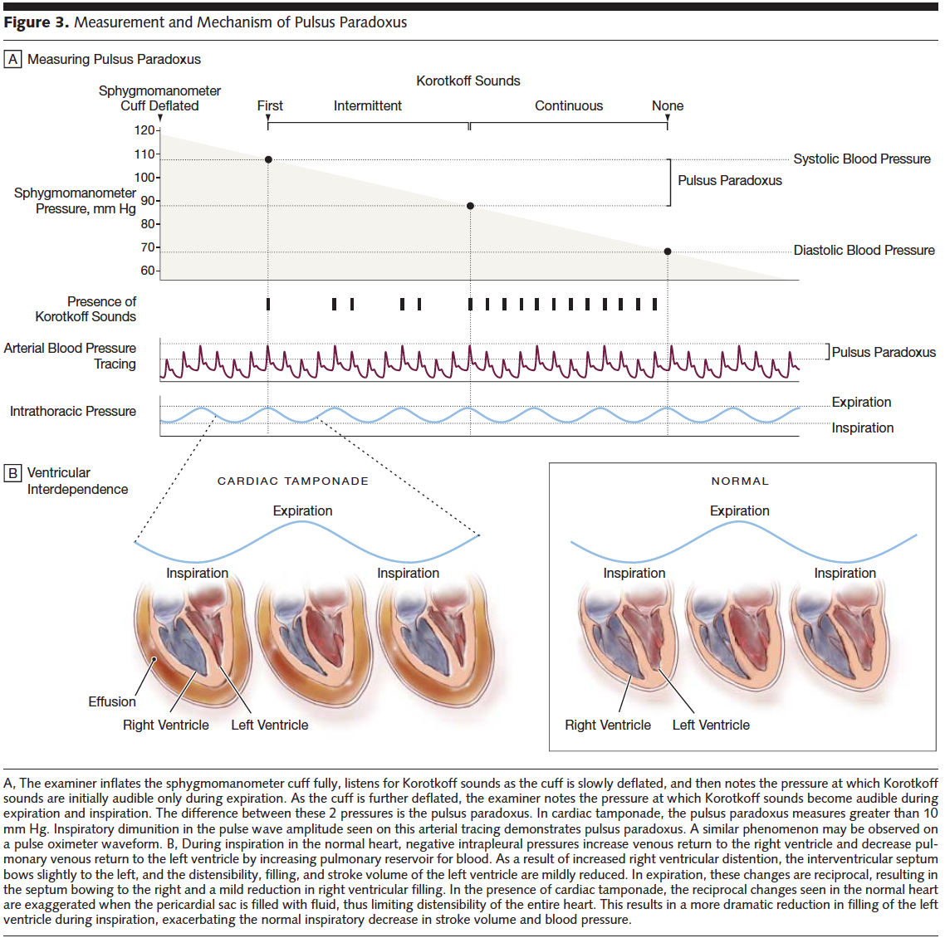
(JAMA, 2007)
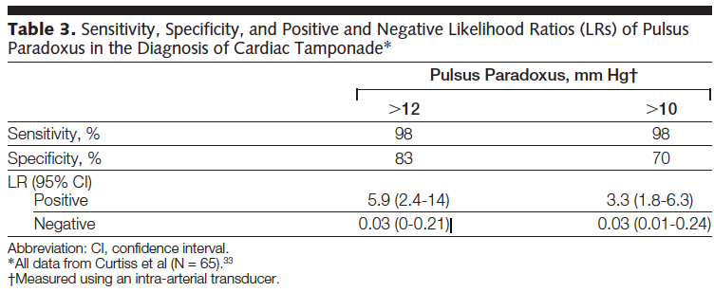.
(JAMA, 2007)
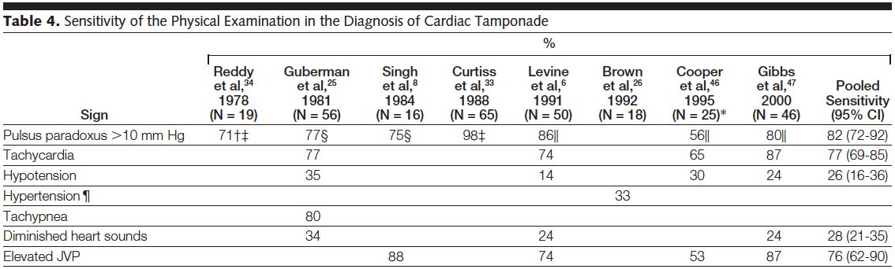
(JAMA, 2007)
- Review the echocardiographic manifestations of cardiac tamponade.
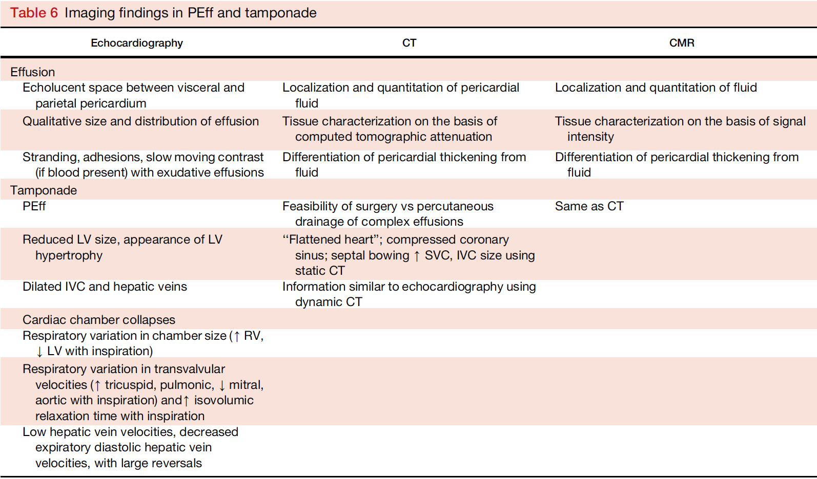
(JASE, 2013)
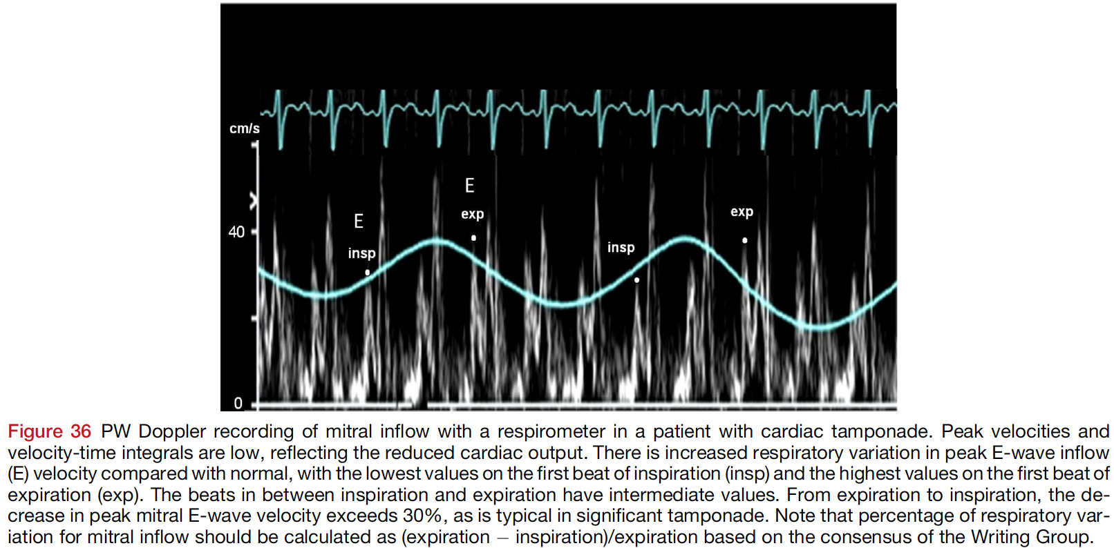
(JASE, 2013)
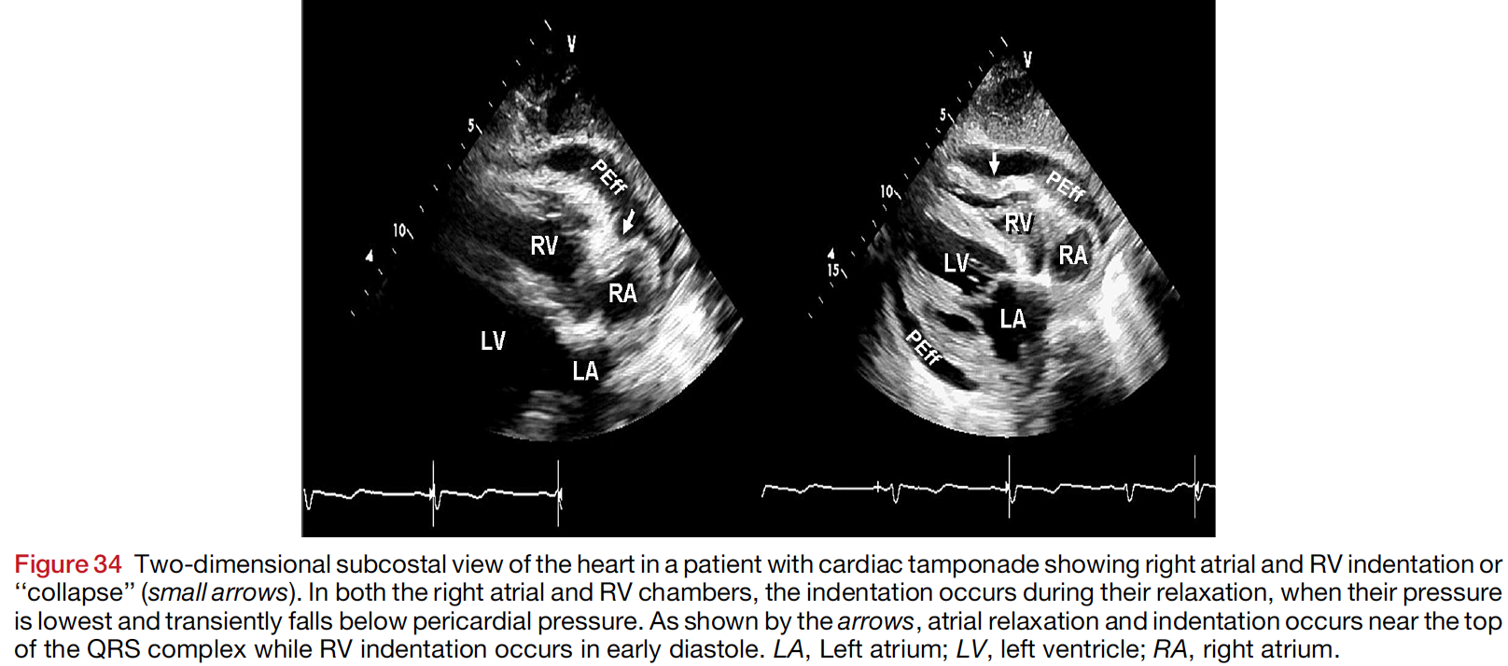
(JASE, 2013)
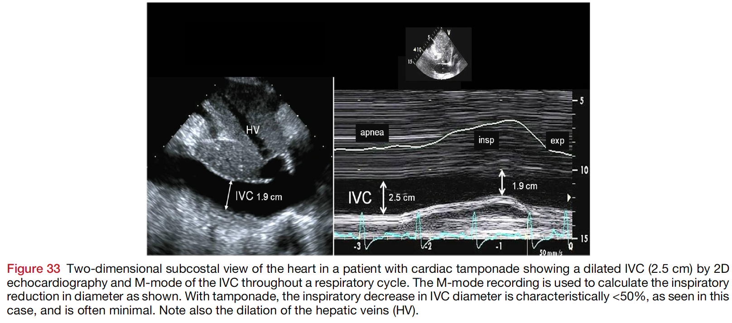
(JASE, 2013)
- Review the pericardiocentesis technique.
Role: Collaborator
- the participant communicates clearly and effectively with the team (closed-loop communication) throughout the simulation.
- The participant demonstrates leadership skills.
Role: Communicator
- The participant takes time to explain the situation and the procedure (pericardiocentesis) to the patient.
- The participant makes sure the patient is comfortable throughout the procedure and responds to the patient’s worries.

